Operational

Data

User Guide

Gas Operations

Version 2

Contents
Contents 1
Market Information Provision Initiative (MIPI) 2
Prevailing View 4
Instantaneous Flows 5
Report Explorer 6
Data Item Explorer 6

Version 2 Operational Data User Guide

Market Information Provision Initiative (MIPI)
What is MIPI?

Market Information Provision Initiative (MIPI) is a web-based, information platform that serves market participants with a wide-ranging view of Gas Transmission operational data. Managed by National Grid, and accessed via our Transmission Operational Data webpage.
Why does National Grid provide market information?
National Grid currently provides information for a number of reasons:
- Special Condition 8F: Provision of Information of National Grid’s NTS Licence;
- National Grid’s obligated data set as defined by UNC Section V9, initiated through GB regulated requirements;
- EU Legislation and EU Code requirements to provide data in our role as TSO;
- Additional data provided by National Grid which was historically viewed as useful for the industry;
- Distribution Network data and Storage Operator data which is the responsibility of these industry sectors, but been made available through MIPI at the request of Ofgem.

Version 1

O
perational Data

User Guide
4

●

Version 1

●

Sources of Information

Prevailing View
Our Prevailing View tool provides a snapshot of real time data and associated contextual data that in turn, illustrates at a high-level, the current status of the National Transmission System (NTS).

Prevailing View also provides lots of other graphs and live data providing further details about the current status of the NTS. For example: Within Day and Predicted Closing Linepack, Instantaneous Flows into the NTS and Instantaneous Supply Data and Storage Stock Position.

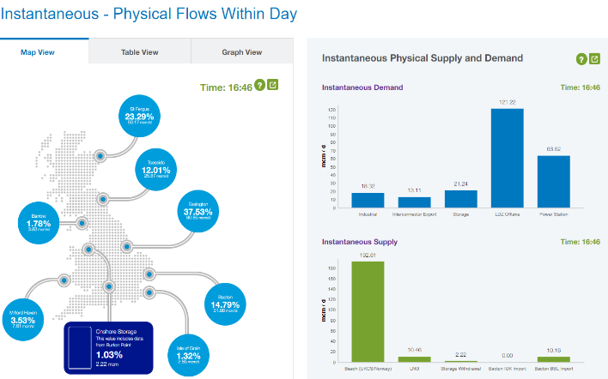

Each graph also has a small green question mark in the top right corner which provides further detail about the data displayed in the graphs.

Instantaneous Flows
This report allows users to access real time flow data for system entry points. The information is captured every two minutes and published at twelve-minute intervals.

Current gas day that the data is for

Report Explorer
Report Explorer provides data in several pre-defined report formats that are categorised according to publication schedule. The data is limited to a singular gas day or month, which is dictated by the user.
Reports can be found by expanding the menu’s
Search function
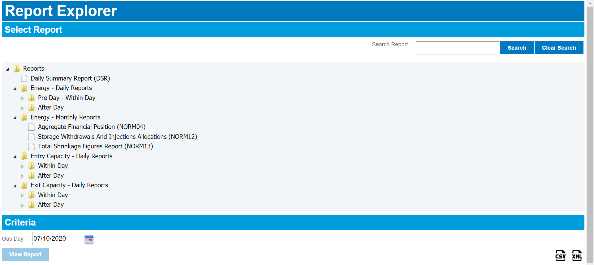
Once you have selected the report and gas day you want to view the data for you can select this option to download the data in CSV file format
Here you enter the singular gas day or month you would like to view the report for

How to Use:
- Select the report you wish to view.
- Enter the Criteria (Gas Day).
- Then choose whether to view via the web browser by selecting ‘View Report’ or download by selecting the ‘Download in CSV / XML’.

Data Item Explorer
All data is available at an individual data item level, enabling users to select a combination of items at their choice. These are categorised in expanding menus and listed according to their subject. Users can select combinations of items of their choice.
In general, 5 years of rolling historic data can be accessed for most data items but some items may have less than 5 years of data, if introduced less than 5 years ago.

Criteria
Latest Values- ensure this is ticked to receive the most up to date values for the data items.
Applicable at- (calendar day the data was published)
Applicable for- (the gas day the data is applicable for)
From Date/To Date- date range you wish to view the data for
Data items- available by expanding the menus

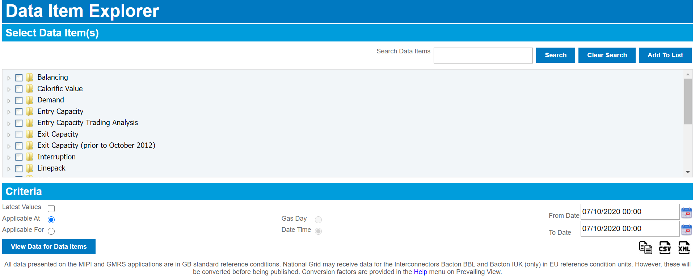
Data Results
You can choose from:
View data for data items- view the data for the data items in you internet browser. Or:
Download the data in CSV or XML file formats

How to Use:
- Select the individual Data Items that you require.
- Enter the Criteria, including the time frame in which you would like the data to be displayed.
- Then choose whether to view via the web browser by selecting ‘View Data for Data Items’ or download by selecting the ‘Download in CSV / XML’.

2

Version 1

Operational Data

User Guide
29

●

Version 1

●

Acronyms

Acronym | Term | Definition
CWV | Composite Weather Variable | A single measure of daily weather. It is the combination of temperature and other weather variables, including wind speed. The purpose of CWV is to define a linear relationship between the weather and non-daily metered gas demand.
D |  | Data generated for a particular gas day during the gas day is classified by D.
D- |  | Data pertaining to gas days in the future are classified as D-x, where x is the number of days prior to the gas day the data is generated.  For example, the earliest forecast of NTS Demand is generated five days before the gas day in question and is referred to as the D-5 forecast.
D+ |  | Data generated for a particular gas day, after the gas day has occurring is classified as D+x, where x is the number of days after the gas day the data was generated.
DM | Daily Metered | Sites with meters which read on a daily basis. Readings provided via daily read equipment (DRE) and sent via telemetry. Class 1 sites are daily metered.
EOD | End of Day | End of the Gas Day (04:59).
GDW | Gas Deficit Warning | A GDW is given at National Grid discretion, based on expectations of the impact of a significant supply/demand event. A GDW will be issued in advance of or during a gas day if a significant supply/demand event is experienced which instigates a material risk to the physical end-of-day balance.
GMRS | Gas Market Reporting System | One of two publication services offered as part of MPI. It populates Instantaneous Flows.
kWh | Kilowatt Hour
LDZ | Local Distribution Zone | A gas distribution zone connecting end users to the Gas  National Transmission System. Operated by Distribution Companies
LNG | Liquefied Natural Gas | LNG is formed by chilling gas to -161oC so that it occupies 600 times less space than in its gaseous form. LNG terminals operate in the UK receiving supplies by ship and importing into the NTS.
MIPI | Market Information Provision Initiative | This forms part of the data which is provided on National Grid’s Operational Data pages:  https://www.nationalgridgas.com/data-andoperations/transmission-operational-data
National Grid | Operational Data User Guide 30
MN | Margins Notice | An MN is information provided to all NTS users, indicating a potential supply/demand imbalance for the coming gas day. An MN is issued from 13:00 D-1, following an assessment of the expected available supply level against forecast total system demand. If demand is greater than supply (by any value), an MN will be issued via ANS. See also DMN.
MSCM | Million Squared Cubic Meters
NSS | Non-Storage Supply | Gas that comes from sources other than gas storage. This includes supply from the UK Continental Shelf (UKCS), Norwegian imports, European imports and imports of liquefied gas (LNG).
NTS | National Transmission System | A high-pressure gas transportation system consisting of compressor stations, pipelines, multijunction sites and offtakes NTS pipelines transport gas from terminals to NTS offtakes and are designed to operate up to pressure of 94 bar(g)
OPNs | Offtake Profile Notices | A commercial tool used to make short term access to system flexibility available to users, over and above contractual rights.
PCLP | Predicted Closing Linepack | By assessing the predicted inputs and offtakes we can determine whether the system is likely to be within the acceptable operational range of ‘balance’ throughout the Gas Day. We publish a predicted closing linepack (PCLP) at regular intervals during a Gas Day based on the information we receive from industry parties.
SO | System Operator | The department of National Grid which manages the realtime operation of our networks. Transmission operator (TO) is a separate department which manages our assets. Operational Forum is organised by SO.
UIG | Unidentified Gas | An amount of Gas which could not be attributed to any system user. As only a minority of supply points submit daily reads into the allocation process, the remainder of gas is allocated based on estimates and historic data. Xoserve aims to support customers to understand and manage UIG further  https://www.xoserve.com/index.php/unidentified-gas-uig/
UNC | Uniform Network Code | The Uniform Network Code is the legal and commercial framework that governs the arrangements between the Gas Transporters and Shippers operating in the UK gas market. The UNC comprises different documents including the Transportation Document (TPD) and Offtake Arrangements document (OAD). You can find all of these documents on Joint office: https://www.gasgovernance.co.uk/

National Grid | Operational Data User Guide 31
National Grid

|

Operational Data User Guide
32

National Grid plc

National Grid House,

Warwick Technology Park,

Gallows Hill, Warwick.

CV34 6DA United Kingdom

Registered in England and Wales

No. 4031152

nationalgrid.com

