Margins Notice
Operational Guidance Material

October 2022

Operational Guidance Material
This document forms part of a suite of documents created to provide operationally focused guidance material; the aim of which is to support Shippers in increasing their understanding of non-routine commercial tools utilised by National Grid so that Shippers can be suitably prepared and ready to participant ahead of an event.
The Operational Guidance Documents detail the optimum way to perform the relevant process based on the current systems available. Where there are alternative ways in which the process could be completed the associated risks and benefits are explored. These documents are not intended to be used as detailed operating process / procedures; however, they can be used by each Shipper organisation to assist in creating the operational process steps that are right for them.
These documents do not preclude changes or development to commercial tools in collaboration with industry in the future.

Margins Notice Information Overview
This document outlines the circumstances in which the Gas National Control
Centre (GNCC) may issue a Margins Notice (MN) and details the practicalities for
users in receipt of one. The following topics are covered below:
• The objective of a Margins Notice
• Circumstances where a Margins Notice occurs
• Margins Notice Trigger and Forecasts
• Overview of the UNC Margins Notice Process
• Overview of the 7 Day Forecast Margins Notice Process
• Additional Information: Calculation Suma

Objective of a Margins Notice
The intent of a Margins Notice is to provide an early, high level notice to NTS users
of a potential physical imbalance for the upcoming gas day, encouraging them to
consult a rolling Daily Margins Report to reassess their position and ability to
balance. As well as day-ahead and within day information, National Grid also publish forecasts of the potential Margins Notice position up to 7 days ahead

Circumstances when a Margins Notice Occurs

A Margins Notice will be issued if the day ahead (D-1) total NTS forecast system demand is equal to or greater than the Expected Available Supply (EAC). EAC comprises of the sum of the NTS’ Non-Storage Supply (NSS) assumptions plus Liquified Natural Gas (LNG) and Storage Deliverability (SD) that qualifies under the prevailing Safety Monitor requirements.
Should the day ahead (D-1) total NTS forecast system demand be within 95% of the Expected Available Supply (EAC) than alert will also be sent to industry informing them of this.
Safety Monitor requirements are in place so that if required, storage withdrawals can be curtailed, to maintain a buffer for customers who cannot be safely isolated from the gas network for physical balancing. A Margins notice will not be withdrawn for the remainder of the applicable gas day but can be superseded by a Gas Balancing Warning.

Margins Notice Trigger and Forecasts
At Day Ahead if the Demand Forecast is above the Margins Notice trigger value, then a Margins Notice will be published. D-2 to D-7 values are used as an indication the risk of a Margins Notice being published in the week ahead.
This guide covers 2 processes – a UNC defined Margins Notice process (defined in UNC TPD Section V 5.9), which is used the define the Margins Notice trigger at Day ahead stage, and also forecasts for D-2 to D-5. It also includes a newer methodology introduced in 2022, which provides a forecast up to D-7, calculated in a different way to the UNC methodology for a more ‘realistic’ view. The newer methodology is intended to be used as additional information for the industry.

Overview of the UNC Margins Notice Process
The Daily Margins Report is run by the GNCC after 14:00 each day and available online at: https://www.nationalgrid.com/uk/gas-transmission/balancing/margins-notices-and-gas-balancing-notifications
Margins Notice trigger levels and forecasts are also available on Prevailing view;
http://mip-prd-web.azurewebsites.net/
If a GBN is in place, this will be displayed at the top left under “Gas System and Market Status”, the ANS message will also be available on that page. Under “Gas Balancing Notifications” is the level of forecast demand which would be sufficient to trigger a Margins Notice; this can be compared against the forecast demand to give an indication of the current relative conditions of the NTS.
Should the daily process identify that a Margins Notice is required, it will be issued to all NTS users during D-1 in the format of an ANS, including the date of the following gas day for which the notice applies and information regarding further data for users.

Figure 1 Margins Notice Trigger and Forecast Demand on Prevailing view (D and D-1):
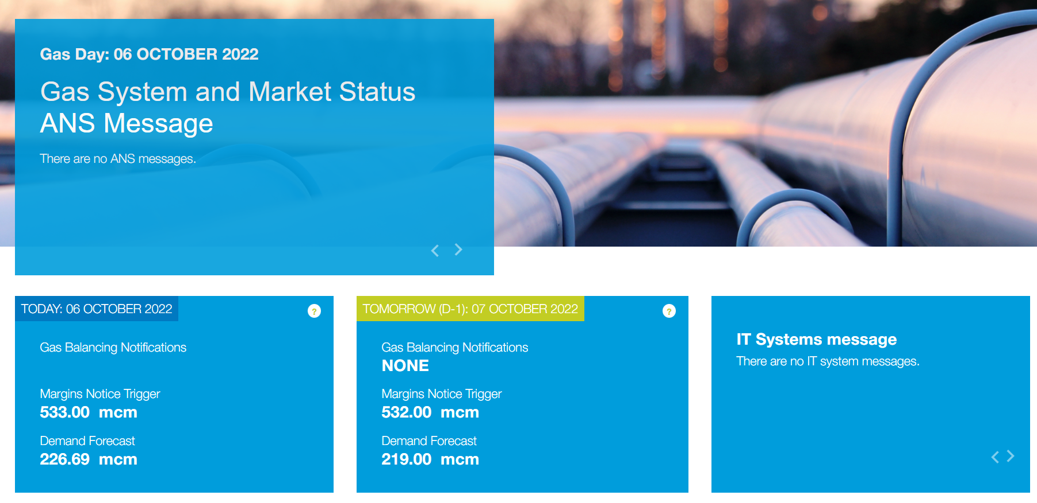

Figure 2 UNC Methodology Daily Margins Notice Report
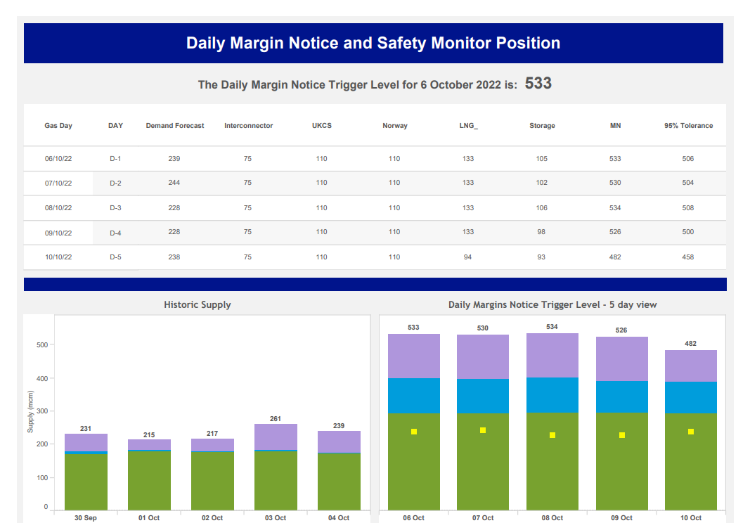

Figure 3 Process for issuing a Margins Notice:
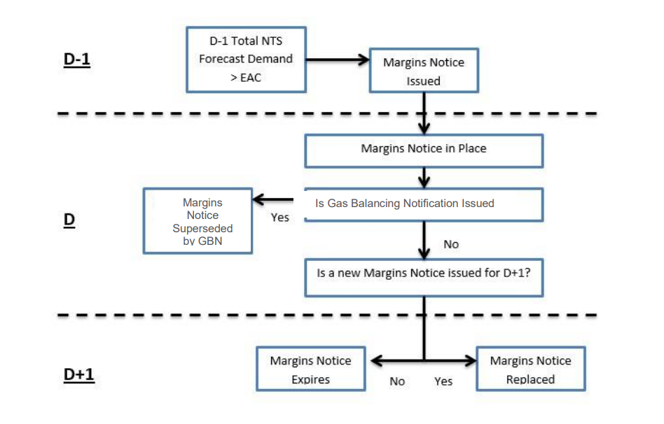

7 Day ‘Forecast’ Margins Notice Process
For winter 2022 National Grid have introduced an additional 7 Day Margins Notice Forecast methodology. This is not a UNC obligation but published to provide a more ‘realistic’ view which also provides a longer-term forecast. The 7 day report will be published on a Friday, with a 5 day updated published every other day during the week, with the same methodology.
In addition to the report the forecast Margins Notice using this methodology will be published on Prevailing View for D-2 to D-7. These are published on Prevailing View instead of the UNC methodology figures as a more accurate view.

Figure 4 7 Day Margins Notice Forecast Report
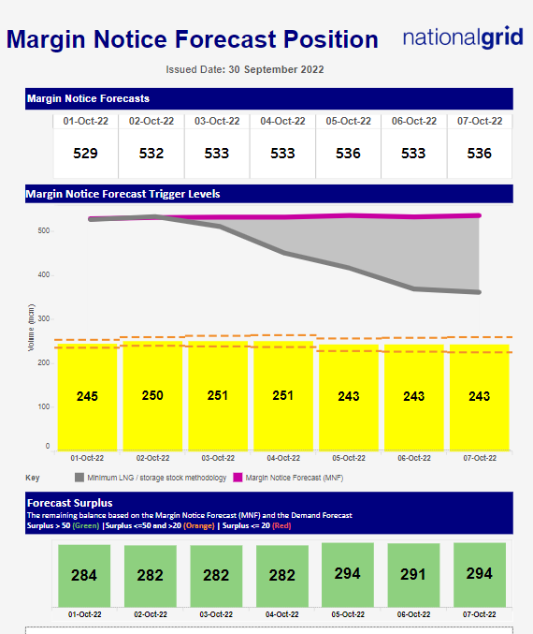
Figure 5 Prevailing View Publication
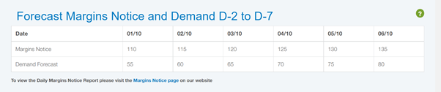

Additional Information: Calculation Summaries
- UNC Margins Notice
The below methodology is outline in UNC TPD Section V 5.9

NSS
The NSS (Non-storage/LNG supply) are determined by National Grid using best available information and may be revised anytime throughout the winter. There is no specific UNC methodology for calculating these numbers. The NSS categories are UKCS, Norway, EU Interconnector Import.

LNG
Determine the below constants prior to the winter:
- Cold weather capability = 95th percentile of each LNG sites flows over the last 3 gas years
- Minimum stock level* = lowest stock level seen in each LNG site over the last 3 gas years + 18 days’ worth of boil off (minimum deliverable volume)
*if this number is higher than previous years then the previous years number should be used
Each day the following calculation is used to determine LNG component of margins notice:
- Useable stock = Current stock – Minimum stock level
- LNG component = Min (cold weather capability, useable stock / 2)
- Subtract this from the current stock and apply above logic for D-1 to D-5

Storage
Each day the following calculation is used to determine Storage component of margins notice:
- Take current stock level of storage site and identify max deliverability based on decay curve as provided by the site prior to the winter
- Subtract this number from the stock and reapply the above logic for D-1 to D-5
- Margins Notice Forecast
The below methodology is not a UNC obligation but is published as additional information for the market and is designed to provide a more ‘realistic’ view.

NSS
As per UNC Methodology.

LNG
Each day the following calculation is used to determine LNG component of margins notice:
- Minimum stock level = lowest stock level seen in each LNG site over the last 3 gas years + X days’ worth of boil off (minimum deliverable volume)
- X days is determined by the number of days until the next boat scheduled to dock at each site
- Useable stock = Current stock – Minimum stock level
- LNG component = Min (7-day average of LNG flows, useable stock / 2)
- Subtract this from the useable stock and apply above logic for D-1 to D-7

Storage
Each day the following calculation is used to determine Storage component of margins notice:
- Take current stock level of storage site and identify max deliverability based on decay curve as provided by the site prior to the winter
- Subtract the 7 day average withdrawal for each site from the stock and reapply the above logic for D-1 to D-7

National Grid plc
National Grid House,
Warwick Technology Park,
Gallows Hill, Warwick.
CV34 6DA United Kingdom
Registered in England and Wales
No. 4031152

nationalgrid.com

