|  |  |
| --- | --- |
| Issue | Revision |
| 9.1 | For Consultation |



Exit Capacity Substitution and Revision Methodology Statement

**Effective from dd mm 2023**

**EXIT CAPACITY SUBSTITUTION AND REVISION METHODOLOGY STATEMENT**

**Document Revision History**

|  |  |  |
| --- | --- | --- |
| **Version**/  **Revision Number** | **Date of**  **Issue** | **Notes** |
| 0.1 | June 2010 | First draft issued for informal consultation. |
| 0.2 | November 2010 | Formal consultation; updated following informal consultation.  Substitution to apply for capacity releases from Y+4 only (see para 19l)  Capacity covered by a financial commitment excluded from Substitutable Capacity (see para 19k  Recipient exit point order changed. Highest revenue driver selected first (see para 27).  Additional flow diagrams added – Annex 1  Exchange rate collar removed.  Clarification of process to set initial flows in substitution analysis (see paras 44 and 45).  Partial substitution included subject to suitable revenue driver. Criteria clarified.  National Grid discretion to override methodology in case of unsatisfactory outcomes removed.  Clarification on availability of capacity whilst substitutions are being considered (see paras 19j and 71). |
| 0.3 | January 2011 | Submission draft.  Modification to paragraph 19k to widen scope for financial commitment to exclude capacity from being substitutable.  New paragraph 24 added to clarify availability of substituted capacity at the donor exit point until the effective date of the substitution. |
| 1.0 | 31 March 2011 | v0.3 Approved by the Authority. Implementation date 1 July 2011  Consistent with the Authority's approval letter, National Grid will temporarily exclude capacity at GB interconnectors from exit substitution. |
| 1.1 | February 2012 | Annual Review.  General updates;  Reference to overriding EU Directive added;  New criteria for defining “Substitutable Capacity” at Interconnector exit points added (see paragraph 19m);  Criteria for selecting Recipient NTS Exit Point added (see paragraph 28);  Clarifications added to network analysis steps following lessons learned with initial application of the methodology in 2011;  Annex 1 – Diagrams updated. |
| 1.2 | April 2012 | No material changes following consultation. |
| 2.0 | May 2012 | Approved by the Authority without change |
| 2.1 | February 2013 | Updated for RIIO-T1.  New terminology and Licence references  General Updates  Annex1 – Diagrams updated |
| 2.2 | March 2013 | Minor changes from 2.1 to correct typing, referencing and formatting errors.  Link in paragraph 70 amended.  Paragraph 26, Licence reference changed.  Submitted for Approval |
| 3.0 | May 2013 | V2.2 approved by the Authority subject to: Paragraph 18 d: revised proposed change to remove potential for NG discretion.  Paragraph 26 revised to give greater clarity to process for recipient NTS Exit Point selection and to Licence reference for revenue drivers |
| 3.1 | September 2013 | Annual Review (informal consultation)  Updated to align to Modification 0452: Introduction of the Planning and Advanced Reservation Capacity Agreement (PARCA) |
| 3.2 | December 2014 | Annual Review (formal consultation)  Minor updates following informal consultation.  Further review to align to Modification 0465V: ‘Introduction of the Planning and Advanced Reservation Capacity Agreement (PARCA), Weighted Average PARCA Security’ and the revised Licence arrangement. |
| 3.3 | January 2015 | Minor changes following industry consultation to improve clarity.  Submitted for Approval |
| 4.0 | February 2015 | Authority Approval subject to a number of minor clarifications |
| 4.1 | December 2014 | Informal consultation  Clarifications arising from development of Modification 0500: EU Capacity Regulations - Capacity Allocation Mechanisms with Congestion Management Procedures |
| 4.2 | July 2015 | Annual Review (formal consultation)  Updates following informal consultation.  Minor updates based on recommendations from 2015 Examination. |
| 4.3 | August 2015 | No further changes following consultation.  Submitted for Approval |
| 5.0 | October 2015 | Authority Approval subject to a number of minor clarifications. |
| 5.1 | October 2016 | Formal Consultation  Updates to substitution lead time and utilisation of unsold capacity at disconnected NTS Exit Points. |
| 5.2 | November 2016 | No further changes following consultation.  Submitted for approval. |
| 6.0 | January 2017 | Authority Approval. |
| 6.1 | April 2017 | Industry consultation: Update to align to UNC Modification 0597: Rules for the release of incremental capacity at Interconnection Points. |
| 6.2 | May 2017 | No further changes following consultation. Submitted for approval. |
| 7.0 | July 2017 | Authority Approval. |
| 7.1 | January 19 | Preliminary Consultation. Housekeeping. |
| 7.2 | March 19 | Formal Consultation. No further changes following preliminary consultation. |
| 7.3 | May 19 | For approval. No further changes. |
| 8.0 | July 2019 | Authority Approval. |
| 8.1 | March 2021 | Formal Consultation  Updated Licence references to align with RIIO T2 changes going live from 1st April 2021  Amendment to prioritise substitution from disconnected sites  Change substitution increment size from 0.01 to 0.1 GWh/d.  Update to Paragraph 22: exclusion of ECP forecasted capacity from ‘Substitutable Capacity’ |
| 8.2 | April 2021 | Ofgem submission. No changes following the consultation. |
| 9.0 | June 2021 | Authority Approval. |
| 9.1 | February 2023 | Formal consultation. Housekeeping, including updating “National Grid” to “National Gas Transmission” |

**ABOUT THIS STATEMENT**

This Exit Capacity Substitution and Revision Methodology Statement (the “Statement”)[1] describes the methodology that National Gas Transmission in its role as holder of the Gas Transporter Licence in respect of the NTS[2] (“the Licence”) will utilise to determine proposals for Exit Capacity Substitution and Exit Capacity Revision, i.e.:

* the substitution of unsold ***Non-incremental Obligated Exit Capacity[3]***from one NTS Exit Point[4] to another in response to the demand for ***Incremental Obligated Exit Capacity***; and/or
* the revision to Licence Baseline Exit Capacity at NTS Exit Points in response to the release of ***Funded Incremental Obligated Entry Capacity***.

In particular, it defines:

* under what circumstances National Gas Transmission will consider such substitutions and revisions; and
* the process to be undertaken by National Gas Transmission to determine its proposals to substitute capacity and revise baseline quantities.

This Statement is one of a suite of documents that describe the release of NTS capacity by National Gas Transmission and the methodologies behind them. The other documents are available on our website at:

https://www.nationalgas.com/capacity/capacity-methodology-statements

This Statement has been published by National Gas Transmission in accordance with Special Condition 9A of the Licence. National Gas Transmission believes the content is consistent with its duties under the Gas Act and is consistent with the Licence.

This Statement contains terminology relating to exit capacity which is used in the Licence and in the Uniform Network Code (“UNC”). Licence defined capacity terms are given in ***bold italics;*** UNC defined capacity terms appear in **bold*.*** Other defined terms used but not defined in this Statement shall have the meaning given to them in the UNC and/or Licence as appropriate.

This Statement of the exit capacity substitution methodology applies in respect of ***Incremental Obligated Exit Capacity*** released as a result of valid applications for **Enduring Annual NTS Exit (Flat) Capacity** or Technical Interconnection Point Capacity, made in accordance with the Uniform Network Code (“UNC”) and the Exit Capacity Release (“ExCR”) methodology statement. The timing of the release of any ***Incremental Obligated Exit Capacity*** will be in accordance with the ExCR methodology statement. Where such ***Incremental Obligated Exit Capacity*** is to be made available and is met via exit capacity substitution, capacity will be made available from a date consistent with this Statement.

This Statement of the exit capacity revision methodology applies in respect of ***Funded Incremental Obligated Entry Capacity*** released pursuant to a PARCA[5] or IP PARCA[6].The effective date for the release of any ***Exit Capacity*** made available as a result of exit capacity revision will be in accordance with this Statement.

Due to the high degree of similarity between the exit capacity substitution and revision methodologies National Gas Transmission has prepared this single document to satisfy the Licence requirements outlined above.

It should be noted that this Statement does not provide the methodology by which, and from when, ***Exit Capacity*** will be made available. The processes for Users to obtain, and for National Gas Transmission to release, ***Exit Capacity*** can be found in the UNC and the Exit Capacity Release methodology statement (“ExCR”).

In the event that the application of the methodology detailed in this Statement results in a proposal to revise the level of ***Non-incremental Obligated Exit Capacity*** at one or more NTS Exit Points which is approved by the Authority, National Gas Transmission will publish such revisions in the Exit Capacity release obligation summary report.

If you require further details about any of the information contained within this Statement or have comments on how this Statement might be improved please contact our Gas Market Change Delivery team at: [box.transmissioncapacityandcharging@nationalgrid.com](mailto:box.transmissioncapacityandcharging@nationalgrid.com) or at:

Gas Market Change Delivery

National Gas Transmission

National Grid House

Warwick Technology Park

Gallows Hill

Warwick

CV34 6DA

Contents

General Introduction 8

Background 8

Capacity Terminology 8

National Gas Transmission’s Licence Obligations 9

CHAPTER 1: PRINCIPLES 11

Purpose of the Methodology Statement 11

CHAPTER 2: EXIT CAPACITY SUBSTITUTION 12

Introduction 12

Process 15

Enduring Annual NTS Exit (Flat) Capacity and Technical Interconnection Point Capacity Applications 15

Recipient NTS Exit Point Order 15

Donor NTS Exit Point Order 16

Investment Analysis 18

Substitution Analysis 19

Partial Substitution 21

Analysis Output 22

CHAPTER 3: EXIT CAPACITY REVISION. 24

Introduction 24

Process 24

User Applications 24

Recipient NTS Exit Point 25

Investment Analysis 25

Revision Analysis 26

Analysis Output 27

Annex 1: Indicative Gas Flow Direction in the NTS for each LDZ. 28

Annex 2: PARCA Supporting Information 35

# General Introduction

## Background

1. National Gas Transmission is the owner and the operator of the gas National Transmission System (NTS) in Great Britain.
2. The NTS plays an important role in facilitating the competitive gas market and helping to provide the UK with a secure gas supply. It is a network of pipelines, presently operated at pressures of up to 94 barg, which transports gas safely and efficiently from coastal terminals and storage facilities to exit points from the system. Exit points are predominantly connections to Distribution Networks (DNs), but also include storage sites, and direct connections to large industrial consumers, power stations, and other systems, such as interconnectors to other countries.
3. These operations are carried out to meet the needs of the companies that supply gas to domestic, commercial and industrial consumers and to power stations.
4. This Statement sets out the methodology that applies for the substitution of

Substitutable Capacity (as defined in paragraph 22) from one or more donor NTS Exit Points to meet demand for ***Incremental Obligated Exit Capacity*** (i.e. capacity to be made available above the prevailing level of ***Obligated Exit Capacity***) at other NTS Exit Points thereby reducing the need for investment to meet that incremental demand for ***Exit Capacity***. The methodology is applicable in respect of the allocation of **Enduring Annual NTS Exit (Flat) Capacity** or Technical **Interconnection Point Capacity** in response to signals received from Users through processes described in the UNC.

1. This Statement also sets out the methodology that applies for the revision to ***Licence Baseline Exit Capacity*** where the release of ***Funded Incremental Obligated Entry Capacity*** (i.e. capacity above the prevailing level of ***Obligated Entry Capacity***), in accordance with the Entry Capacity release (“ECR”)methodology statement, creates additional NTS exit capability.
2. Details of National Gas Transmission and its activities can be found on its internet site at https://www.nationalgas.com/. An electronic version of this Statement, along with other related statements can be found on the following web page:

https://www.nationalgas.com/capacity/capacity-methodology-statements

## Capacity Terminology

1. This Statement contains terminology relating to ***Exit Capacity*** which is used in the Licence for the purposes of distinguishing between National Gas Transmission’s capacity obligations and revenue treatments. It should be noted that although this terminology exists, it does not change the capacity products that Users procure through established UNC processes e.g. **NTS Exit (Flat) Capacity** and **NTS Exit (Flexibility) Capacity.**
2. The terminology and relationships relating to ***Firm Exit Capacity*** are provided below to assist the reader in interpreting this Statement.

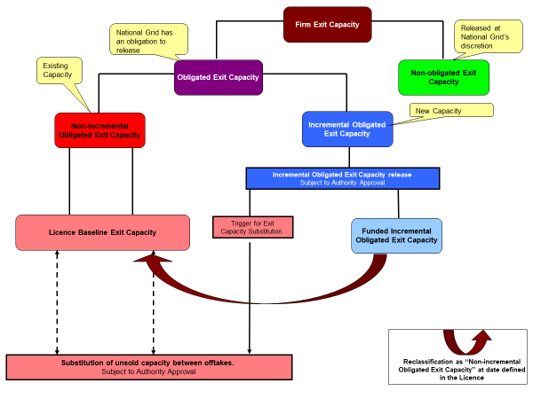

1. The actual definitions of these terms are contained within the Licence. Where any conflict arises between the Licence and this Statement the Licence shall prevail.

## National Gas Transmission’s Licence Obligations

1. New and existing Users of the NTS are able to request to purchase **NTS Exit Capacity**[7] products defined in the UNC for any NTS Exit Point defined in the Licence. Such capacity requests will be considered against the provisions of National Gas Transmission’s statutory and Licence obligations and in accordance with its published methodologies.
2. Overriding obligations applicable to this statement are set out in the Gas Act, Regulation (EC) No. 715/2009 of the European Parliament and the Council[8] and the Licence.
3. Specific obligations in respect of the release of ***Exit Capacity*** and relevant to this Statement are set out in Special Condition 9.18 of the Licence. Under this condition, National Gas Transmission must prepare a capacity release methodology statement (the “ExCR”) setting out the methodology by which National Gas Transmission will determine whether to make ***Exit Capacity*** available for sale. The current ExCR methodology statement can be found on National Gas Transmission’s website.
4. The specific obligations applicable to this Statement set out in the Licence in respect of the Substitution of Exit Capacity and the revision of Licence Baseline Exit Capacity are:

* *Special Condition 9.17.9(a) - ensuring that each of ……. Exit Capacity Substitution ………. and Exit Capacity Revision are effected in a manner consistent with National Gas Transmission’s duties under the Act and, in particular, the duty to develop and maintain an efficient and economical pipeline system and its obligations under the Licence;*
* *Special Condition 9.17(b)(ii) - Exit Capacity Substitution is effected in a manner which seeks to minimise the need to make an application under Special Condition 3.13 (Funded incremental obligated capacity Re-opener and Price Control Deliverable), taking into account the Exit Capacity that shippers and DN Operators have indicated that they will require in the future through making a financial commitment to the licensee.*

1. Special Condition 9.17.9 also sets out the capacity objectives that the methodologies should seek to meet. In addition to the criteria in paragraph 13 these objectives are (as per Special Condition 9.17.9):

(c) Ensuring that exit capacity substitution / revision is effected in a manner which is compatible with the physical capability of the NTS;

(d) Avoiding material increases in the costs (including Entry Capacity and Exit Capacity Constraint Management costs in respect of ***Obligated Entry Capacity*** and ***Obligated Exit Capacity*** previously allocated) that are reasonably expected to be incurred by National Gas Transmission as a result of Exit Capacity Substitution or Exit Capacity Revision; and

(e) In so far as is consistent with (a), (and where relevant) (b), (c) and (d) above, facilitating effective competition between relevant Shippers, DN Operators and relevant Suppliers.

1. This Statement has been produced to meet the requirements of Special Condition 9.17 of the Licence in respect of the preparation of Capacity Methodology Statements setting out the methodologies by which National Gas Transmission will determine its proposals for the substitution & revision of ***Non-incremental Obligated Exit Capacity*** pursuant to the obligations in paragraphs 2(a) and (b) of the above stated condition. National Gas Transmission believes the content is consistent with its duties under the Gas Act and Regulation (EC) No 715/2009 of the European Parliament and the Council and is consistent with the Licence. National Gas Transmission will, through exit capacity substitution:

* make additional ***Obligated Exit Capacity*** available at the recipient NTS Exit Point, and
* reduce the quantity of ***Obligated Exit Capacity*** available at the donor NTS Exit Point,

in quantities determined in accordance with this Statement. The obligation to provide ***Exit Capacity*** at the donor NTS Exit Point is reduced by the quantity determined and such substituted capacity (including subject to 22b, capacity reserved for substitution pursuant to a PARCA or IP PARCA) will not be available for sale in future at the donor NTS Exit Point.

# CHAPTER 1: PRINCIPLES

## Purpose of the Methodology Statement

1. The methodology detailed in this Statement is intended to promote the economic and efficient development of the NTS. For the purposes of this methodology this objective is achieved by seeking to minimise the amount of investment that is required to satisfy incremental demand for ***Exit Capacity***. Specifically, the methodology describes:

* how capacity could be identified as suitable for substitution from locations where there is no long term demand for capacity (as defined by the availability of ***Non-incremental Obligated Exit Capacity*** that has not been sold or reserved pursuant to a PARCA or IP PARCA) to other locations where ***Funded Incremental Obligated Exit Capacity*** would otherwise be required to be released as a result of accepted applications for **Enduring Annual NTS Exit (Flat) Capacity** or to satisfy a request for capacity through a PARCA or IP PARCA. Subject to the further provisions of this Statement, any available unsold ***Non-incremental Obligated Exit Capacity*** that is not allocated, or reserved will be deemed available for substitution; and
* how additional ***Exit Capacity*** is to be made available at locations on the NTS as a result of the release of ***Funded Incremental Obligated Entry Capacity***.

1. The methodology described in this Statement seeks to ensure that the NTS is efficiently sized by avoiding or minimising investments by the development of proposals for consideration by the Authority to substitute or revise ***Non-incremental Obligated Exit Capacity*** levels. This may occur under the following circumstances:

* where
  1. Users at an NTS Exit Point have requested additional **Enduring Annual NTS Exit (Flat) Capacity**
  2. where PARCA Applicants at an NTS Exit Point have requested additional **Enduring Annual NTS Exit (Flat) Capacity** pursuant to a PARCA
  3. where IP PARCA applicants at an Interconnection Point have requested **Interconnection Point Capacity** pursuant to an IP PARCA.

in accordance with UNC processes that in aggregate exceed the existing ***Obligated Exit Capacity*** level, National Gas Transmission will consider whether it would be efficient and economic to seek to release the additional ***Exit Capacity*** required at that NTS Exit Point by the **substitution** of unsold ***Non-incremental Obligated Exit Capacity*** from other NTS Exit Points. This is described in Chapter 2;

* where the release of ***Funded Incremental Obligated Entry Capacity*** (in accordance with the ECR methodology statement) increases the exit capability of the NTS, National Gas Transmission will consider whether it would be efficient and economic to seek to increase the availability of ***Exit Capacity*** by the **revision** of ***Licence Baseline Exit Capacity*** at one or more NTS Exit Points. This is described in Chapter 3.

1. Consistent with the Licence and UNC, **NTS Exit Capacity** is a commercial right that may be offered on a daily basis or multiples thereof: it does not reflect a commitment or obligation upon National Gas Transmission to undertake any investment on its network, including, but not limited to the provision of a physical connection to the NTS.

# CHAPTER 2: EXIT CAPACITY SUBSTITUTION

## Introduction

1. This section explains the step by step approach that National Gas Transmission will undertake in order to develop proposals for submission to, and approval by, the Authority to reduce the level of ***Non-incremental Obligated Exit Capacity*** at one or more NTS Exit Points to facilitate an increase to the level of ***Non-incremental Obligated Exit Capacity*** elsewhere so as to avoid the need to release ***Funded Incremental Obligated Exit Capacity*** and hence to minimise the need for investment in the NTS.
2. Before application of the methodology set out in this Statement demand for ***Incremental Obligated Exit Capacity*** must be established. This will occur where Users apply for **Enduring Annual NTS Exit (Flat) Capacity** in excess of the prevailing ***Obligated Exit Capacity*** in accordance with UNC processes and the ExCR.
3. Demand for ***Incremental Obligated Exit Capacity*** may also be established pursuant to a PARCA. Under a PARCA, the PARCA Applicant may apply[9] for **Enduring Annual Exit (Flat) Capacity** which may be in excess of the prevailing ***Obligated Exit Capacity*** level. Similarly demand for Incremental **Interconnection Point Capacity** may be established pursuant to an IP PARCA. Where works carried out under the PARCA or IP PARCA, identify that the additional capacity can be provided by substitution, the ***Non-incremental Obligated Exit Capacity*** identified for substitution will be reserved pending substitution.

1. In applying the methodology for substitution set out in this Statement the following rules will be applied to determine the quantity of ***Exit Capacity*** that will be made available for substitution, the “Substitutable Capacity”. Under no circumstances will capacity be substituted from an NTS Exit Point in quantities greater than the Substitutable Capacity. Subject to the following rules, Substitutable Capacity at an NTS Exit Point shall be equal to the unsold quantity of ***Non-incremental Obligated Exit Capacity*** (as defined in the Licence):
   1. Capacity currently allocated (see sub paragraph j) as **Enduring Annual NTS Exit (Flat) Capacity**[10] or **Technical Interconnection Point Capacity** will not be available for substitution, i.e. sold capacity will not be Substitutable Capacity.
   2. Capacity currently reserved (see sub paragraph j) will not be Substitutable Capacity.

Where a PARCA is terminated prior to the allocation of capacity any capacity reserved pursuant to the PARCA, will be made available as **Unsold NTS Exit Capacity** and as such will become Substitutable Capacity if that capacity is Non-incremental Obligated Capacity. Where the **Reserved Exit Capacity** is at a different NTS Exit Point to where the PARCA has indicated the need for additional capacity (i.e. capacity is reserved pending substitution), the **Reserved Exit Capacity** will become Substitutable Capacity at the donor NTS Exit Point.

* 1. Capacity currently allocated (see sub-paragraph j) as **Annual NTS Exit (Flat) Capacity** for any Day on or after the proposed date of release of the relevant ***Incremental Obligated Exit Capacity*** will not be Substitutable Capacity.
  2. NTS Exit Capacity required as a result of demand forecasts provided via Exit Capacity Planning processes as per Standard Special Condition A57 and the Exit Capacity Planning Guidance, will not be Substitutable
  3. Except where the further provisions of this paragraph 22 apply, capacity that has previously been substituted to an NTS Exit Point will be Substitutable Capacity from the date where future quantities of that capacity are unsold, and not reserved at that recipient NTS Exit Point.
  4. Because substitution of capacity is indefinite, capacity that has already been substituted from a donor NTS Exit Point will not be available as Substitutable Capacity in respect of that donor NTS Exit Point on subsequent occasions.
  5. Any ***Incremental Exit Capacity*** released as a result of long term signals received in accordance with UNC and the ExCR that has subsequently become unsold will not be Substitutable Capacity until that incremental capacity is re-classed, for the purposes of the Licence, as ***Non-incremental Obligated Exit Capacity***[11].
  6. For each NTS Exit Point the quantity of Substitutable Capacity will be the lowest value, determined in accordance with this paragraph, for any Day from the proposed date for the substitution to be effective, i.e. the date of release of the relevant ***Incremental Obligated Exit Capacity***.
  7. Any ***Exit Capacity*** at a notional exit point created as a result of Exit Capacity Revision (see Chapter 3) shall be Substitutable Capacity.
  8. Where there are valid[12] applications for capacity (including agreed and signed PARCAs and IP PARCAs) received in the same application period (for the purposes of this Statement, Phase 1[13] and Phase 2 of a PARCA/IP PARCA shall be considered an “application period”) as the application(s) for which capacity substitution is being considered, any ***Exit Capacity*** identified as being required to be allocated to (or reserved for) Users (or PARCA/IP PARCA Applicants) to satisfy those applications shall not be Substitutable Capacity. This ensures that any capacity requested, but not allocated (or reserved) at the time of the substitution analysis, is not considered as Substitutable Capacity if it is required to satisfy applications for capacity at that NTS Exit Point at that time.
  9. Consistent with paragraph 80, and subject to paragraph 22j, where valid ad-hoc and PARCA Applications are received for **Enduring Annual NTS Exit (Flat) Capacity**, any available unsold ***Non-incremental Obligated Exit Capacity*** required to satisfy the application shall, except where paragraph 22b applies, be Substitutable Capacity. This ensures that capacity required for substitution cannot be sterilised by an ad-hoc or PARCA/IP PARCA Application unless backed up by a financial commitment[14].

* 1. Any ***Non-incremental Obligated Exit Capacity*** that is unsold after 1st October Y+2[15] is Substitutable Capacity with respect to demand for Enduring Annual NTS Exit (Flat) Capacity or Technical Interconnection Point Capacity, signalled either via the Annual Application Window (July), via an ad-hoc application or via a PARCA or IP PARCA. For clarity unsold capacity does not include **Reserved Exit Capacity** and the Y is the year where either Capacity has been applied for or capacity has been first reserved via a PARCA or IP PARCA. Except in respect of sub-paragraph i, any capacity available for use before 1st October Y+2 will not be Substitutable Capacity.
  2. In respect of Interconnection Points (as identified as such in Appendix 2 of Special Condition 9.13 of the Licence) the **Technical Interconnection Point Capacity** of the downstream connected system at the Interconnection Point shall not be Substitutable Capacity.

1. Following each application for ***Exit Capacity*** (including agreement of a PARCA or IP PARCA), demand for ***Incremental Obligated Exit Capacity*** will be identified. If ***Incremental Obligated Exit Capacity*** is not required then no further action need be taken by National Gas Transmission.
2. If, in accordance with the ExCR, National Gas Transmission considers that it is appropriate to release ***Incremental Obligated Exit Capacity*** then the methodology in this Statement shall be applied to see whether the quantity of ***Incremental Obligated Exit Capacity*** required to be released can be reduced through Exit Capacity Substitution. For the avoidance of doubt, the User Commitment (as defined in the ExCR) shall apply to all capacity increases of Enduring Annual NTS Exit (Flat) Capacity (except as specified in the ExCR) irrespective of whether the increase is satisfied through investment (including contractual alternatives) and/or substitution and/or existing capability.
3. In respect of any application, excluding agreement of a PARCA or IP PARCA, capacity will only be considered available for substitution after all applications or bids for unsold ***Exit Capacity*** have been satisfied, i.e. capacity will be allocated at the NTS Exit Point where applications are received before being substituted to another NTS Exit Point.
4. In respect of any PARCA or IP PARCA, capacity will only be considered available for reservation pending substitution after all applications or bids for existing unsold capacity[16] have been satisfied, i.e. capacity will be allocated at the NTS Exit Point where applications or bids are placed before being reserved pending substitution to, another NTS Exit Point. Notwithstanding paragraph 22b, once capacity has been substituted or reserved pending substitution it will not be available to satisfy applications for capacity at that NTS Exit Point in future.
5. National Gas Transmission will consider information received and will determine whether additional ***Exit Capacity*** requests can be satisfied by the substitution of Substitutable Capacity from other NTS Exit Points. The overriding factor in such consideration will be to minimise the amount of investment that is required to satisfy incremental demand for ***Exit Capacity***, without increasing the assessed risk of incurring other costs, e.g. operational costs or capacity buy-back costs, to meet National Gas Transmission’s capacity obligations in respect of other NTS Exit Points and of NTS Entry Points.
6. Capacity will only be available to be substituted from an NTS Exit Point in the quantity determined in accordance with paragraph 22.
7. Where Exit Capacity Substitution is applied the ***Non-incremental Obligated Exit Capacity*** at the donor NTS Exit Point shall be reduced by the quantity, determined in accordance with this Statement, from the date when ***Incremental Obligated Exit Capacity*** is available for use at the recipient NTS Exit Point. In the period prior to this date the capacity will be available to Users at the donor NTS Exit Point, but this will not be “enduring” capacity.

## Process

## Enduring Annual NTS Exit (Flat) Capacity and Technical Interconnection Point Capacity Applications

1. In accordance with the UNC and the ExCR, Users can apply for additional **Enduring Annual NTS Exit (Flat) Capacity** at the Annual Application Window (July) or via an ad-hoc application or by entering into a PARCA with National Gas Transmission[17]. Similarly, in accordance with the UNC and the ExCR, Users can apply for additional **Technical Interconnection Point Capacity** at an Exit IP via the IP Auctions or by entering into an IP PARCA with National Gas Transmission. Reservation Parties / Reservation Users can also reserve capacity by entering into a PARCA or an IP PARCA with National Gas Transmission. In addition, Users are able to apply for a reduction to their registered **Enduring Annual NTS Exit (Flat) Capacity** either during the Annual Application Window or in response to an ad-hoc reduction invitation from National Gas Transmission.
2. If Users or Reservation Parties request additional **Enduring Annual NTS Exit (Flat) Capacity** at any NTS Exit Point or **Technical Interconnection Point Capacity** at an Exit IP, that in aggregate exceeds the level of unsold ***Obligated Exit Capacity***, considering any valid reduction requests, National Gas Transmission will undertake the following process for each such NTS Exit Point. Where there is more than one such NTS Exit Point these may be grouped according to their location on the NTS in order to minimise substitution analysis requirements, i.e. NTS Exit Points generating the requirement for similar investment projects can be grouped together. For each group or individual NTS Exit Point the process described below under “Substitution Analysis” will be repeated by iteration to identify the optimum ***Non-incremental Obligated Exit Capacity*** decreases to maximise the reduction in required investment. The objective is, therefore, to reduce investment, not to reduce exchange rates (ratio of ***Non-incremental Obligated Exit Capacity*** decrease to ***Incremental Obligated Exit Capacity*** release avoided).

## Recipient NTS Exit Point Order

1. Subject to paragraph 31, where ***Exit Capacity*** applications[18] result in National Gas Transmission identifying the need to release ***Incremental Obligated Exit Capacity*** at more than one NTS Exit Point and they share the same potential donor NTS Exit Point, analysis of substitution opportunities will be undertaken according to a ranking of recipient and donor NTS Exit Point pairings by their exchange rate, (see paragraphs 32 to 44).

## Donor NTS Exit Point Order

1. Substitution from notional exit points created as a result of Exit Capacity Revision (see Chapter 3) shall be considered before substitution from NTS Exit Points. Substitution from a disconnected NTS Exit Point[19], which would provide reasonably sufficient benefit (i.e. there is a reasonably sufficient exchange rate) to a recipient NTS Exit Point (to be determined at National Gas Transmission’s sole discretion), shall be considered next before substitution from other NTS Exit Points, as set out in paragraph 45.
2. National Gas Transmission will deem the benefit as reasonable and sufficient if the exchange rate of the disconnected site does not exceed 3:1. If the exchange rate is greater than 3:1, National Gas Transmission will proceed with the prioritisation of a disconnected site only in a scenario where it is reasonable to assume that no future Incremental Obligated Exit Capacity signal triggering a need for substitution will require capacity from this disconnected site in the future. National Gas Transmission will make that assessment based on e.g. forecast demand information and flow patterns in the area, indication of new future network connections (if available), pending PARCAs in the vicinity of the donor site. The list is not inclusive and further factors might be considered as a part of the assessment at National Gas Transmission’s discretion.
3. Substitution from a disconnected site is the only scenario in which exchange rate exceeding 3:1 might be used, subject to the assessment mentioned in para 34.
4. Disconnected sites will only be considered to be prioritised when it falls within the geographical area considered within substitution analysis as outlined in paragraphs 37, 42 and 43.
5. Substitutions from individual donor NTS Exit Points will commence by reducing the capacity at the most favourable NTS Exit Point that has Substitutable Capacity. The most favourable NTS Exit Point will normally be, and is assumed to be, the furthest downstream NTS Exit Point from the recipient NTS Exit Point as measured by pipeline distance. The furthest downstream is selected as it is assumed to provide the lowest exchange rate so should result in the most efficient outcome.
6. Due to the complexity of the NTS and the range of supply/demand scenarios assessed as part of the substitution analysis, it may not always be apparent:

* which NTS Exit Point is the furthest downstream. In order to simplify analysis, potential donor NTS Exit Points on the same pipeline as the recipient NTS Exit Point will be considered before those on adjacent connected pipelines; or
* whether NTS Exit Points are downstream or upstream of the recipient NTS Exit Point. This will be determined by network analysis at each stage of the substitution process, e.g. an NTS Exit Point may move from being upstream to downstream as a result of substitution of capacity at a previous donor NTS Exit Point.

To provide an indication of the relative position of NTS Exit Points the diagrams in Annex 1 have been produced. These show the direction of gas flow in the NTS for each LDZ under typical high demand conditions, i.e. the supply / demand scenario used to determine NTS Transmission Transportation Charges. This scenario is not necessarily representative of the supply / demand scenario that will be used for substitution analysis.

1. Potential donor NTS Exit Points shall be ignored where they are too far downstream (or upstream) to provide a benefit to the recipient NTS Exit Point. This will be determined by the application of the exchange rate cap (see paragraph 43).
2. In the event of two or more potential donor NTS Exit Points being an equal distance from the recipient NTS Exit Point then the donor NTS Exit Point providing the lowest calculated exchange rate will be selected. In the event that exchange rates are equal, capacity shall be reduced first at disconnected donor NTS Exit Points and then at each other relevant donor NTS Exit Point, in proportion to the available Substitutable Capacity at each of these donor NTS Exit Points.
3. Where there is insufficient capacity at the first donor NTS Exit Point to fully satisfy the ***Incremental Exit Capacity*** required at the recipient NTS Exit Point the quantity of capacity that can be substituted will be substituted and further donor NTS Exit Points will be considered:

* in accordance with paragraphs 32 to 40; then
* upstream of the recipient NTS Exit Point, starting with the nearest and extending upstream until either a compressor or beach ASEP is reached.

1. Upstream donor NTS Exit Points will be selected on the same basis of, pipeline, pipeline distance, exchange rate, then pro-rating, as for downstream donor NTS Exit Points.
2. When considering the second, and subsequent, donor NTS Exit Points consideration shall be given to possible changes in gas flow direction as a result of substitutions already identified. This may change the sequence of potential donor NTS Exit Points.
3. The exchange rate for each donor / recipient NTS Exit Point pairing shall be determined. Where this exceeds 3:1 the substitution, or part thereof, shall not be permitted. Substitution at 3:1 and below will be made to the extent[20] that this is possible. As subsequent donor NTS Exit Points, for that recipient NTS Exit Point, are unlikely to be possible at less than or equal to 3:1 further analysis will not be necessary except to verify that this is the case.
4. Subject to the above criteria and the objective to reduce necessary investment, donor NTS Exit Points shall be selected in the sequence:

* Notional exit points[21];
* Disconnected sites;
* Downstream NTS Exit Points on the same feeder;
* Downstream NTS Exit Points on adjacent connected feeders;
* Upstream NTS Exit Points on the same feeder;
* Upstream NTS Exit Points on adjacent connected feeders.

## Investment Analysis

1. For each recipient NTS Exit Point, National Gas Transmission will carry out network analysis to identify a network model (the “enhanced network”) that meets existing obligations. This analysis shall be undertaken consistent with the process outlined in (paragraphs 49 to 52). Substitution and investment proposals to satisfy requests for ***Incremental Exit Capacity*** shall be incremental to this base network.
2. For any NTS Exit Point at which all ***Incremental Exit Capacity*** requests can be met without undertaking NTS investment[22] (and/or giving rise to increased operational costs), i.e. within the capability of the enhanced network, National Gas Transmission will consider the release of ***Incremental Obligated Exit Capacity*** consistent with the new aggregate level of capacity allocations (and reservations). Where such requests cannot be met without investment (and/or giving rise to increased operational costs), National Gas Transmission will investigate exit capacity substitution opportunities.
3. Potential capacity substitutions shall be validated through network analysis. The objective shall be to avoid incremental increase in risk. Hence National Gas Transmission will not propose capacity substitution where this would result, under planning scenarios, in the capability of the NTS to meet existing obligations being reduced.
4. The Exit Capacity Substitution objective is to minimise investment that would otherwise be required to satisfy demand for ***Incremental Exit Capacity***. Substitution opportunities shall be assessed against criteria defined within the Transmission Planning Code which is the basis for National Gas Transmission’s network development decisions. This shall include existing commitments, including **NTS Exit (Flat) Capacity**, **NTS Exit (Flexibility) Capacity** and Assured Offtake Pressures (as defined in UNC), on the network. Substitutions shall not be accepted if this reduces National Gas Transmission’s ability to deliver its existing commitments. These commitments will be taken from regulatory and commercial agreements and statutory instruments and are additional to the conditions set out in the Transmission Planning Code.
5. The supply and demand scenarios used for the analysis will be consistent with the Transmission Planning Code a copy of which can be found on the National Gas Transmission website at: https://www.nationalgas.com/charging.
6. The analysis shall primarily be undertaken at high demand levels taking into account the gas security standard as detailed in the Transmission Planning Code. Ideally the flow at all NTS Exit Points should be set at the obligated level. However, this would be impracticable because to do so would result in total exit flow being much greater than previously experienced peak demand and available entry supplies. Hence, normally flows at NTS Exit Points shall be set:

* for NTS Exit Points that have a reasonable probability of being donor NTS Exit Points,[23] at the ***Obligated Exit Capacity*** level (plus any incremental capacity reserved via a PARCA or IP PARCA); and
* for all other NTS Exit Points, to the appropriate level for the demand condition, but no lower than the sold capacity level.

1. Where the process outlined in paragraph 51 is inconsistent with the scenario being assessed, e.g:

* at off-peak[24] demand levels; and
* in consideration of NTS Exit Points, such as storage sites, not expected to normally off-take gas at peak demand levels,

supply and demand flows shall be adjusted consistent with analysis for the determination of ***Funded incremental obligated capacity Re-opener***, and, where appropriate, off-peak load behaviour. Any adjustment shall be consistent with the capacity objectives stated in paragraph 14.

## Substitution Analysis

1. The substitution analysis will be assessed in accordance with the physical capability of the enhanced network including that of the recipient NTS Exit Point local infrastructure. For example, where physical limits exist on the maximum flows that may be achieved at an NTS Exit Point, no substitution that could take flows above this physical maximum will be allowed.
2. Where an application is received for capacity at an NTS Exit Point that would take the total ***Exit Capacity*** allocated (plus any incremental capacity reserved via a PARCA or IP PARCA); to all Users in aggregate, no higher than the quantity of the ***Obligated Exit Capacity*** at that NTS Exit Point, this application will be satisfied by utilising existing system capability determined after consideration of any accepted reduction requests. Capacity substitution and/or funded investment will not be considered as a means to satisfying existing ***Obligated Exit Capacity*** obligations.
3. Where an application is received that requires the release of capacity in excess of the ***Obligated Exit Capacity***, i.e. ***Incremental Obligated Exit Capacity***, analysis is undertaken to determine what capacity exchange rate would be required to satisfy the ***Incremental Exit Capacity requirement*** without the need for investment. Capacity substitution will be determined by assessing the flow patterns that can be accommodated by the enhanced network; i.e. without increasing the risk of capacity constraint management actions being required.
4. Substitution analysis will commence by increasing the flow (in the assessment scenario) at the recipient NTS Exit Point to the level of the prevailing ***Obligated Exit Capacity*** (plus any incremental capacity reserved via a PARCA or IP PARCA). This shall be repeated for all NTS Exit Points as identified in paragraph 51.
5. Flow will be adjusted at the least interactive ASEP to maintain a supply / demand balance.
6. Substitution analysis will continue by increasing the flow (in the assessment scenario) at the recipient NTS Exit Point by the level of the required ***Incremental Obligated Exit Capacity*** rounded up to the nearest 0.1GWh/d.
7. The ***Non-incremental Obligated Exit Capacity*** will be reduced at the donor NTS Exit Point. Where this impacts on flow, rebalancing will be undertaken as in paragraph 57.
8. The ***Non-incremental Obligated Exit Capacity*** at the donor NTS Exit Point will progressively be reduced until either:

* the ***Incremental Obligated Exit Capacity*** requirement is satisfied; or
* all Substitutable Capacity has been substituted; or
* further capacity cannot be substituted without exceeding an exchange rate of 3:1.

1. After all Substitutable Capacity has been used, any unsatisfied ***Incremental Obligated Exit Capacity*** will be considered with the next donor NTS Exit Point. Donor NTS Exit Points will be considered in accordance with paragraphs 32 to 44. Further donor NTS Exit Points will be considered until the criteria in paragraph 60 is satisfied at which point the next recipient NTS Exit Point shall be considered.
2. The reduction step sizes in paragraphs 59 and 60 will be determined by the individual analyst bearing in mind the need to minimise the number of analysis steps and to identify the optimum reduction quantity to satisfy the incremental request, e.g. in respect of a large increment, all the Substitutable Capacity at one or more donor NTS Exit Points may be reduced in one step. The reduction quantity will be a multiple of 0.1GWh/d[25].
3. At each stage of the process, e.g. when moving to an additional donor NTS Exit Point the individual donor NTS Exit Point to recipient NTS Exit Point exchange rate will be determined to ensure compliance with the criteria in paragraph 43.
4. Hence all substitutions shall be subject to a limit on the maximum permitted exchange rate of 3:1. The limit specified in paragraph 60 ensures that the cap is maintained. However, to the extent that some capacity can be substituted from a donor NTS Exit Point at, or lower than, 3:1, substitution will be permitted for that quantity of capacity.
5. To validate results, National Gas Transmission may consider further donor NTS Exit Points. As donor NTS Exit Points are considered in order of potential benefit to the recipient NTS Exit Point it is unlikely that any subsequent donor NTS Exit Points will satisfy the exchange rate limits.
6. The revised ***Obligated Exit Capacity*** and remaining ***Incremental Obligated Exit Capacity*** (and hence flows) for all potential capacity substitutions shall be verified by network analysis. Where such analysis is deemed to result in a “failed” network, the flow at the donor NTS Exit Point(s) (and hence the quantity of capacity substituted from the donor NTS Exit Point(s)) shall be adjusted until the network does not fail or there is no more Substitutable Capacity available. In this event the residual investment[26] needed to facilitate the release of the remaining ***Incremental Obligated Exit Capacity*** shall be identified. Any such remaining ***Incremental Obligated Exit Capacity*** shall be ***Funded Incremental Obligated Exit Capacity***.
7. Where residual investment is identified and the associated cost of this investment is not, in National Gas Transmission’s sole estimation, adequately covered by the return on such investment, potential capacity substitutions will be adjusted. The most economic solution will be proposed taking into account minimum economic investment and substitution quantities.
8. Scenarios where National Gas Transmission may regard the return on investment to be inadequate will include, but not be limited to, where the residual investment:

* is for a small quantity requiring investment below economic pipeline sizes;
* is for a quantity requiring investment at non-standard pipeline/infrastructure sizes or to unsatisfactory connection points to the existing NTS.

1. Where paragraph 67 applies potential substitutions shall be disregarded to the extent necessary to avoid sub-optimal investment and/or partial substitution where a satisfactory revenue driver has not been approved by the Authority and included in the Licence for the residual investment.

## Partial Substitution

1. The appropriate level and combinations of substitution and investment (considering all potential ***Incremental Obligated Exit Capacity*** releases) will be confirmed by network analysis. This will be achieved by updating the network model for the revised, post-substitution, ***Non-incremental Obligated Exit Capacity*** and ***Funded Incremental Obligated Exit Capacity*** levels and residual investment. The final step in the substitution analysis that was undertaken shall be reversed, by 0.1GWh/d, (i.e. by increasing the ***Obligated Exit Capacity*** at the relevant donor NTS Exit Point and where this impacts on flow, rebalancing will be undertaken) and this shall be validated through network analysis.

* If the network fails, e.g. network pressures or plant operating conditions cannot be maintained then the proposed substitutions are deemed to be appropriate.
* If the network passes further 0.1GWh/d increments shall be added to the donor NTS Exit Point flow until the network fails and the cut-off point is identified. Substitutions shall be proposed consistent with the last network model that did not fail.

1. A final adjustment shall be made to the quantities substituted to correct for rounding up the quantity at the recipient NTS Exit Point in paragraph 58. The quantity substituted shall be reduced to the actual level of the ***Incremental Obligated Exit Capacity*** to be released. The quantity substituted from the last (and if necessary earlier) donor NTS Exit Point shall be reduced using the exchange rate determined through the substitution analysis.
2. The process detailed above can result in the requirement for residual investment. This residual investment will be necessary in respect of the release of ***Incremental Obligated Exit Capacity*** at one or more NTS Exit Points and is classified as ***Funded Incremental Obligated Exit Capacity***.
3. National Gas Transmission will expect to be funded in respect of the release of ***Funded Incremental Obligated Exit Capacity*** and this will normally be achieved through  ***Re-opener.***
4. Where partial substitution is proposed National Gas Transmission will make a Funded Incremental Obligated Capacity (FIOC) Submission, as defined in the FIOC Guidance and Submissions Requirement Document as per Licence Special Condition 9.13. This will facilitate the determination of funding, where required, for the incremental quantity to be released.
5. For the avoidance of doubt, where residual investment relates to the whole or part of the quantity of ***Incremental Obligated Exit Capacity*** required at an NTS Exit Point National Gas Transmission reserves the right (in accordance with Part A paragraphs 86 and 94 of the ExCR version 15.0) to reject that application except where a PARCA or IP PARCA has been agreed.

## Analysis Output

1. On completion of the above analysis the effects of the exit capacity applications and accepted exit capacity substitutions will be reviewed. Where National Gas Transmission considers that an accepted substitution is inappropriate, e.g. the proposed reduction in ***Non-incremental Obligated Exit Capacity*** at an NTS Exit Point would create difficulties for the downstream operator to meet their statutory and / or regulatory obligations, National Gas Transmission will discuss with the Authority whether:

* such accepted substitutions should be reversed (notwithstanding that they were determined by following the approved methodology);
* the level of residual investment increased (consistent with the other provisions of this chapter) accordingly; and
* the accepted substitution excluded from National Gas Transmission’s proposals.

1. On completion of the above analysis (and any adjustments pursuant to paragraph 76) the effects of the Exit Capacity applications and accepted Exit Capacity Substitutions will be recorded and proposed to the Authority in the Exit Capacity notice. This notice, outlined in paragraph 78, will be submitted ahead of allocation of capacity to the requesting User. However, in respect of a PARCA/IP PARCA, ahead of the reservation of capacity pending substitution, National Gas Transmission will inform the Authority of that potential capacity substitution and publish in accordance with Special Condition 9.13. This will be at the conclusion of the Phase 1 PARCA Works or the design phase (for an Exit IP)[27], after network analysis has identified Exit Capacity Substitution opportunities, but before (potentially several years before) capacity is allocated to the PARCA/IP PARCA signatory at the recipient NTS Exit Point. The formal Exit Capacity notice shall be submitted ahead of allocation in accordance with Licence Special Condition 9.13, at a time deemed appropriate following discussions with the PARCA Signatory.
2. Specifically National Gas Transmission shall submit:

* An Exit Capacity notice setting out:
* the NTS Exit Points where ***Incremental Obligated Exit Capacity*** is proposed to be released;
* The quantity of ***Incremental Obligated Exit Capacity***; and the quantities proposed to be treated as:
  + ***Funded Incremental Obligated Exit Capacity***; and
  + ***Non-incremental Obligated Exit Capacity***
* The effective date for when the capacity is first made available for use;
* The NTS Exit Points (which for the purpose of this paragraph shall include notional exit points) to which Exit Capacity Substitution proposals relate;
* The proposed quantities by which National Gas Transmission is proposing the ***Non-incremental Obligated Exit Capacity*** shall be increased or decreased as a result of Exit Capacity Substitution;
* The effective date(s) where different to that above, plus
* Any additional information required in accordance with Licence Special Condition 9.13.

These notices will be placed on National Gas Transmission’s website at

<https://www.nationalgas.com/reserving-capacity-parca-and-cam>

1. The proposed adjustments to ***Obligated Exit Capacity*** as a result of Exit Capacity Substitution will be implemented subject to the Authority not vetoing the proposal in accordance with Special Condition 9.13 of the Licence. In the event that the proposal is vetoed National Gas Transmission will not revise the ***Obligated Exit Capacity***. Consistent with the ExCR this may result in applications for **Enduring Annual NTS Exit (Flat) Capacity** or Technical Interconnection Point Capacity being rejected, delayed or allocated in a reduced quantity. Any resulting allocations will be determined following discussion of the options between National Gas Transmission and the counterparty pursuant to the terms of the PARCA or IP PARCA.
2. In the period before substitution proposals are approved or vetoed, there will be uncertainty as to the quantity of unsold ***Exit Capacity*** available to Users and Reservation Parties who wish to apply for additional **Enduring Annual NTS Exit (Flat) Capacity** via the available application processes. During this period National Gas Transmission will determine such quantities to be unavailable for applicants until a decision has been made by the Authority on National Gas Transmission’s substitution proposals. The quantity unavailable shall be equal to the quantity proposed to be substituted away from donor NTS Exit Points or likely, in National Gas Transmission’s opinion, to be included in National Gas Transmission’s substitution proposals. Except where paragraph 22j applies, applications received during this period shall be considered only after capacity at the relevant NTS Exit Point has been confirmed (by National Gas Transmission’s substitution analysis or by Authority veto of National Gas Transmission’s substitution proposals) as not being required for substitution.

# CHAPTER 3: EXIT CAPACITY REVISION.

## Introduction

1. This section explains the approach that National Gas Transmission will undertake in order to develop proposals to revise the ***Licence Baseline Exit Capacity*** at NTS Exit Points due to investments undertaken on the NTS as a result of the release of ***Funded Incremental Obligated Entry Capacity***.
2. Before application of the Exit Capacity Revision methodology, demand for ***Incremental Obligated Entry Capacity*** must be established. This will occur where Users obtain ***Entry Capacity*** in excess of the prevailing level of ***Obligated Entry Capacity*** in accordance with UNC processes and the ECR.
3. As exit capability is dependent upon entry gas flows, and not entry capacity bookings, Exit Capacity Revision will be driven by confidence over gas flows rather than release of ***Entry Capacity*** and/or commissioning of related infrastructure. Dependent upon the nature of the connected operations at an ASEP, it is unlikely that sufficient confidence can be obtained until gas has flowed against the incremental capacity signalled for two years.
4. Where the release of ***Incremental Obligated Entry Capacity*** is satisfied through substitution of ***Entry Capacity*** from one ASEP to another ASEP (see Entry Capacity Substitution methodology statement) National Gas Transmission will not apply this Exit Capacity Revision methodology and ***Licence Baseline Exit Capacity*** will not be revised, i.e. Exit Capacity Revision will only apply in respect of the release of ***Funded Incremental Obligated Entry Capacity***.
5. In addition, where the release of ***Incremental Obligated Entry Capacity*** is satisfied through the release of ***Funded Incremental Obligated Entry Capacity*** and National Gas Transmission pursues alternatives to investment in new infrastructure, National Gas Transmission will not apply this Exit Capacity Revision methodology and ***Licence Baseline Exit Capacity*** will not be revised, i.e. Exit Capacity Revision will only apply in respect of the release of ***Funded Incremental Obligated Entry Capacity*** where investment in new infrastructure occurs.
6. Following the process described below, National Gas Transmission will determine whether, considering its statutory and other obligations, a revision to ***Licence Baseline Exit Capacity*** can be justified to the Authority. National Gas Transmission will after completion of the process provide to the Authority its proposals for Exit Capacity Revision in the Entry Capacity notice and the Exit Capacity notice.

## Process

## User Applications

1. In accordance with the UNC and the ECR, Users can apply for additional ***Entry Capacity*** at the Quarterly System Entry Capacity Auction (QSEC auction) or **Technical Interconnection Point Capacity** via IP Auctions at an IP ASEP.
2. If Users request additional **NTS Entry Capacity** via a PARCA or IP PARCA at any ASEP that in aggregate exceeds the existing ***Obligated Entry Capacity*** level, and these applications satisfy the user commitment (NPV or economic) test detailed in the ECR, National Gas Transmission will undertake the following process for each such ASEP. Where there is more than one such ASEP these may be grouped according to their location on the NTS in order to minimise Exit Capacity Revision analysis requirements.
3. For each group or individual ASEP the process described below under “Revision Analysis” will be repeated to identify the ***Exit Capacity*** increases that can be accommodated as a result of the release of ***Funded Incremental Entry Capacity***. The objective is, therefore, to minimise exit driven investment.

## Recipient NTS Exit Point

1. National Gas Transmission shall create a notional exit point near to the relevant ASEP which shall be the only recipient NTS Exit Point.
2. Where there is an existing NTS Exit Point at an ASEP, the notional exit point shall not be an existing NTS Exit Point.
3. A notional exit point shall be an exit point solely for the purpose of Exit Capacity Revision in accordance with this methodology.
4. Any ***Exit Capacity*** placed at a notional exit point shall be available for Exit Capacity Substitution in respect of future ***Incremental Obligated Exit Capacity*** requirements. Substitution from the notional exit point may occur in the same analysis period as capacity is placed at the notional exit point.

## Investment Analysis

1. Potential Exit Capacity Revisions shall be validated through network analysis. The objective shall be to reduce investment that would otherwise be required to satisfy demand for ***Incremental Obligated Exit Capacity*** whilst avoiding incremental increase in risk.
2. Revision opportunities shall be assessed against criteria defined within the Transmission Planning Code which is the basis for National Gas Transmission’s network development decisions. This shall include existing commitments, including **NTS Exit (Flat) Capacity**, **NTS Exit (Flexibility) Capacity** and Assured Offtake Pressures (see UNC defined terms), on the network. Revisions shall not be accepted if this puts at risk National Gas Transmission’s ability to deliver its existing commitments plus those commitments created as a result of Exit Capacity Revision. These commitments will be taken from regulatory and commercial agreements and statutory instruments and are additional to the conditions set out in the National Gas Transmission annual planning procedures.
3. The supply and demand scenarios used for the analysis will be consistent with the Transmission Planning Code. Of primary importance will be the establishment of entry gas flows. A key factor in the establishment of supply / demand scenarios is identification of the range of realistic and reliable gas supply flow rates. In regard to new ASEPs or incremental capacity at existing ASEPs future flows will not be known at the time that the ***Incremental Entry Capacity*** is released.
4. The analysis shall primarily be undertaken at high demand levels taking into account the gas security standard as detailed in the Transmission Planning Code. Flows shall be set:

* for NTS Exit Points in the vicinity of the relevant ASEP[28], at the ***Obligated Exit Capacity level*** ; and
* for all other NTS Exit Points, to the appropriate level for the demand condition;
* for the relevant ASEP, at the level demonstrated consistently on days of high demand.

## Revision Analysis

1. Where ***Funded Incremental Obligated Entry Capacity*** has been released (and in accordance with paragraph 85) analysis is undertaken to determine how much additional ***Exit Capacity*** can be released as a result. This means that at an existing ASEP, Exit Capacity Revision will only be applied when consistent flows are established in excess of the ***Obligated Entry Capacity*** level before the relevant ***Incremental Obligated Entry Capacity*** release. Capacity revision will be determined by assessing the flow patterns that can be accommodated by the NTS; i.e. without increasing the risk of capacity constraint management actions being required.
2. Revision analysis will commence by increasing the flow (in the assessment scenario) at the relevant ASEP to that which National Gas Transmission is confident will, in normal circumstances, be delivered on high demand days.
3. Flow will be increased (in the assessment scenario) at all NTS Exit Points that have a high level of interactivity with the relevant ASEP to the level of the prevailing ***Obligated Exit Capacity***.
4. Revision analysis will continue by increasing the flow at the notional NTS exit point by the level of increase as was made at the ASEP (paragraph 99)
5. Where the above steps impact on flow, rebalancing will be undertaken at the least interactive ASEP.
6. Revision analysis in respect of each release of ***Funded Incremental Obligated Entry Capacity*** shall be undertaken annually following the July annual application window for ***Exit Capacity***.
7. In respect of a specific release of ***Funded Incremental Obligated Entry Capacity***, the first Exit Capacity Revision analysis shall be undertaken two winters after the commissioning of relevant infrastructure built to support the release of the ***Funded Incremental Obligated Entry Capacity***. This should ensure that certainty of entry flows has been established. However, in the event that consistent flows have not been established the increase in flow in paragraph 99 may be zero (in which case no further analysis is required for that year)
8. In respect of a specific release of ***Funded Incremental Obligated Entry Capacity***, Exit Capacity Revision analysis shall be undertaken annually until the earlier of:

* Demonstration of consistent flows at the ***Obligated Entry Capacity*** level and all capacity placed at the notional exit point has been substituted to an NTS Exit Point; or
* Two years after the initial revision analysis, i.e. three years in total.

1. Where ***Incremental Obligated Entry Capacity*** has been signalled for release in phases, paragraph 105 shall apply in respect of each phase.
2. In respect of revision analysis undertaken in accordance with paragraph 105 the adjustment in flow at the notional exit point, in accordance with paragraph 101 may be an increase, where consistency of flows is progressively increasing, or a decrease if consistency of flows has declined.

## Analysis Output

1. On completion of the above analysis the effects of any Exit Capacity applications and accepted Exit Capacity Revisions will be recorded and proposed to the Authority. Specifically, National Gas Transmission shall submit:

* An Exit Capacity notice as detailed in paragraph 78
* An Entry Capacity notice setting out:
* The notional exit points and ASEPs to which Exit Capacity Revision proposals relate;
* The proposed quantities by which National Gas Transmission is proposing the ***Exit*** ***Capacity*** shall be adjusted at notional exit point(s)[29] as a result of Exit Capacity Revision; and
* The effective date(s)

1. Any proposed adjustments to ***Obligated Exit Capacity*** as a result of Exit Capacity Substitution from notional exit points (i.e. as a result of Exit Capacity Revision) will be implemented subject to the Authority not vetoing the proposal in accordance with Special Condition 9.13 of the Licence. In the event that any of the proposals are vetoed National Gas Transmission will not revise the ***Obligated Exit Capacity*** (nor place ***Exit Capacity*** at notional exit points) and will undertake such investment as National Gas Transmission deems, at its sole discretion, appropriate.
2. In the period following allocation of capacity to Users and before revision proposals are approved or vetoed there will be uncertainty as to the quantity of unsold ***Exit Capacity*** available to Users and Reservation Parties via the IP Auctions, the Annual Application Window and the ad-hoc, PARCA or IP PARCA application processes. During this period National Gas Transmission will determine such quantities to be withheld from applicants until a decision has been made by the Authority on National Gas Transmission’s revision proposals. The quantity withheld shall be equal to the proposed substitution quantities, if known, at recipient NTS Exit Points.

# Annex 1: Indicative Gas Flow Direction in the NTS for each LDZ.

Note: The direction of gas flow in the NTS for these diagrams was determined from the gas charging model based on 2020/21 network. Substitution analysis may be undertaken for a range of supply/demand scenarios which could result in different flow patterns. The following diagrams are not definitive and should be used for indicative guidance only.

Key.





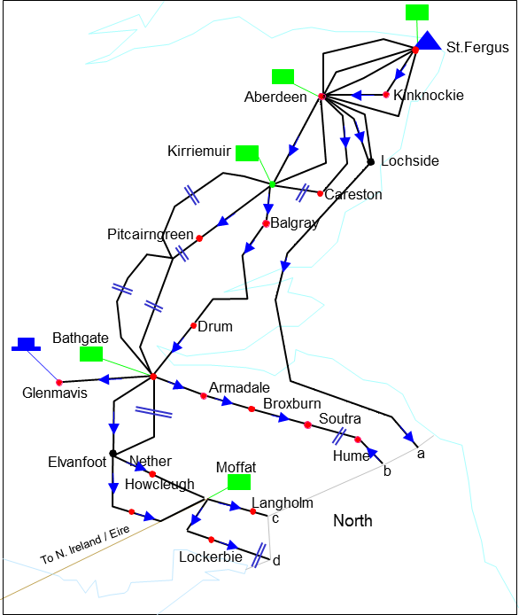



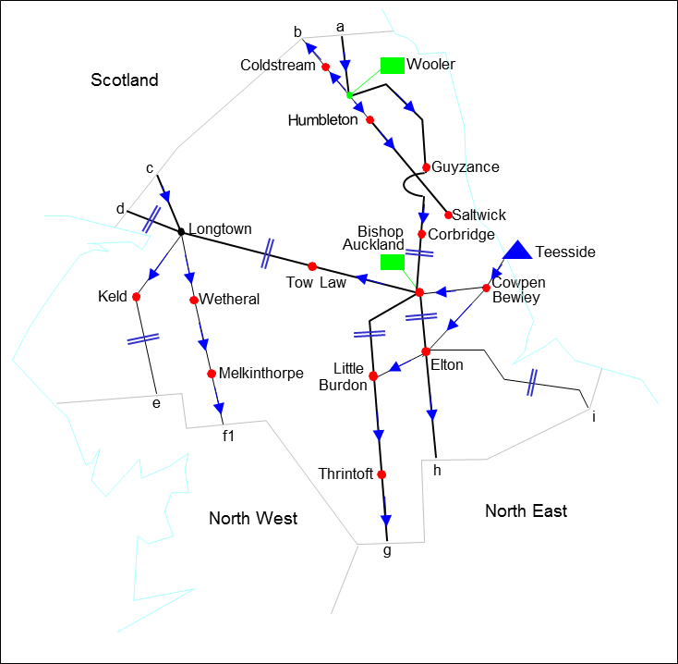



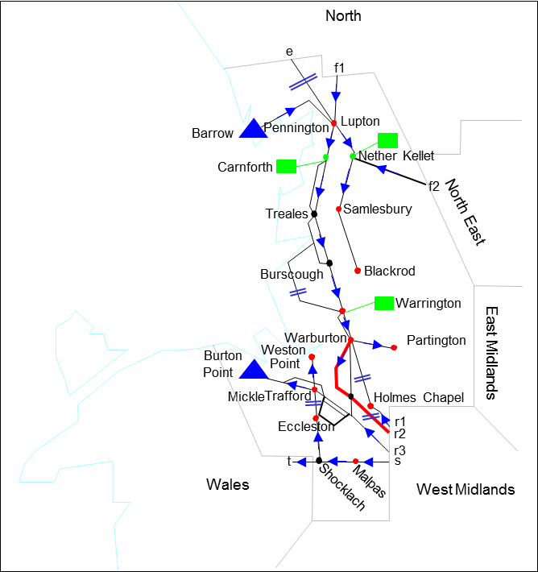



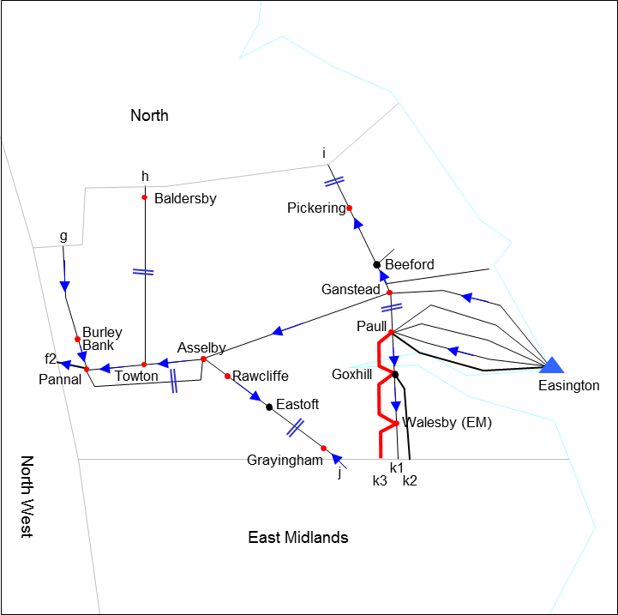



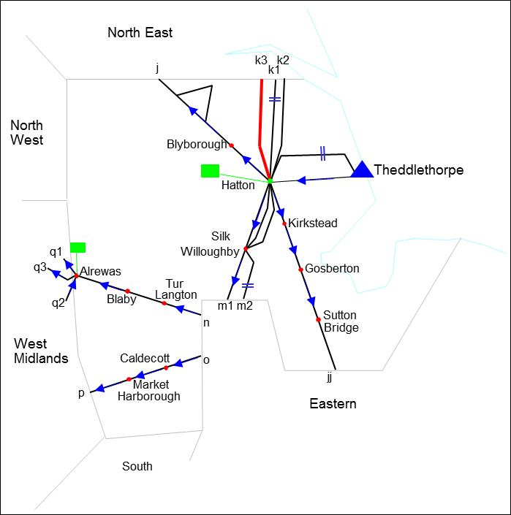



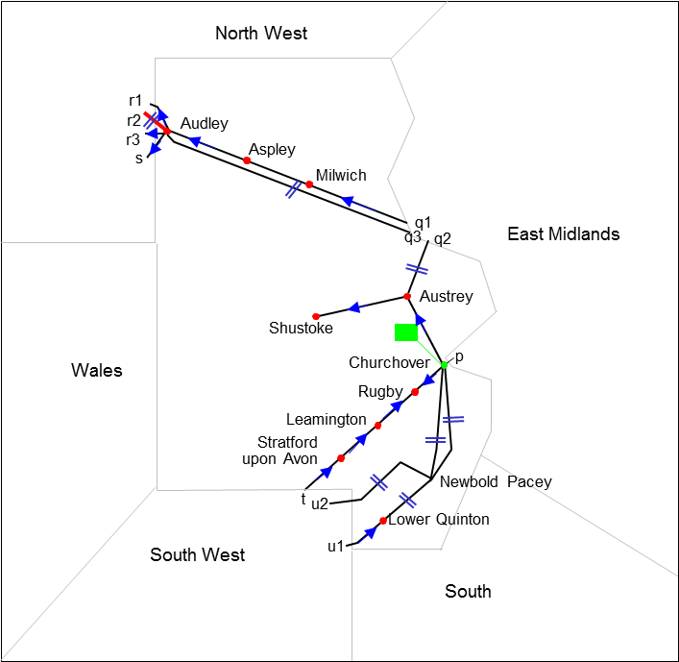



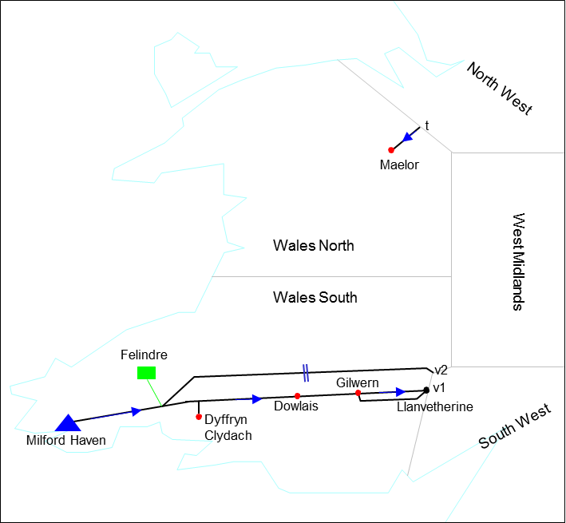



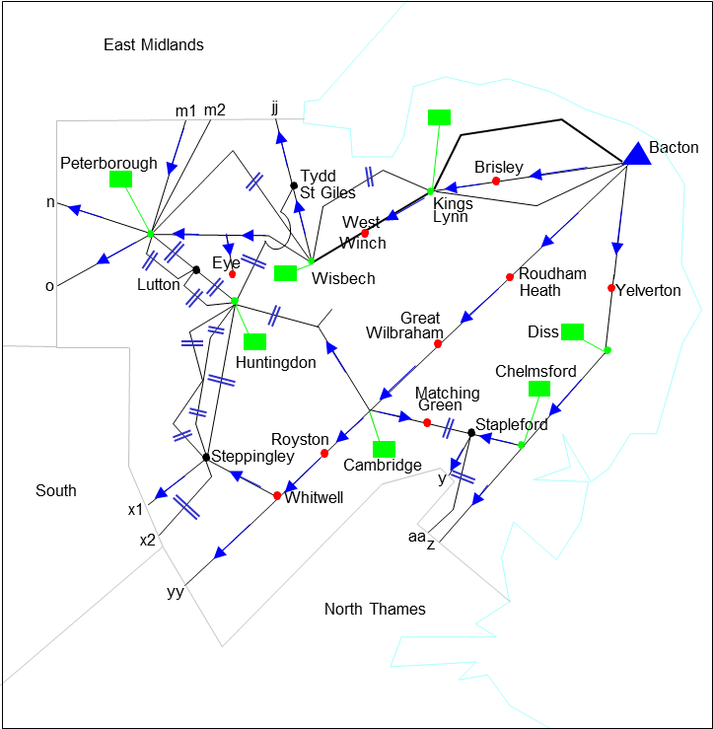



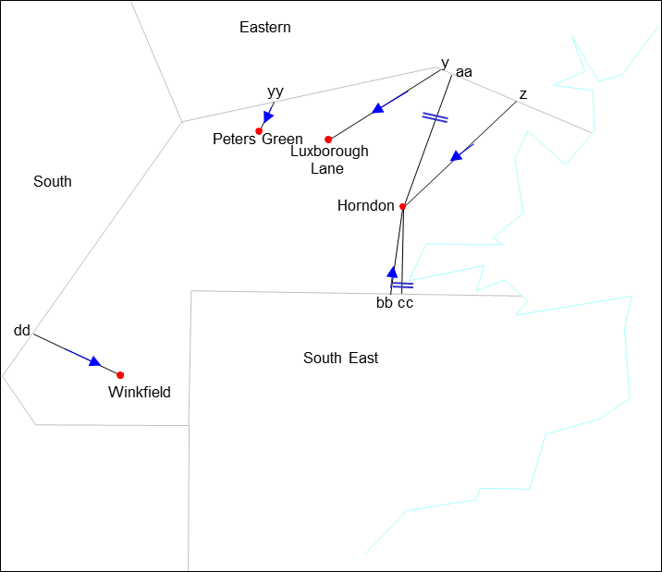



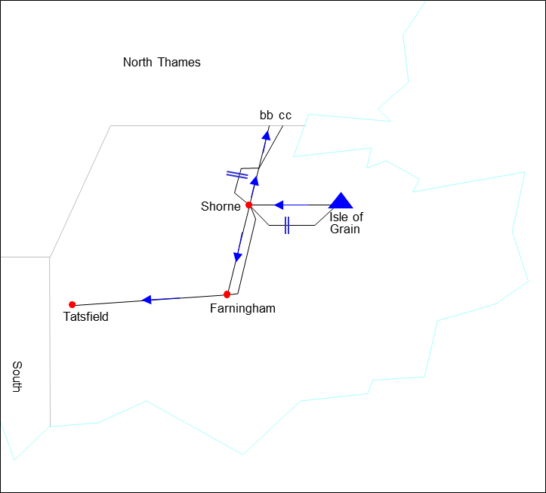



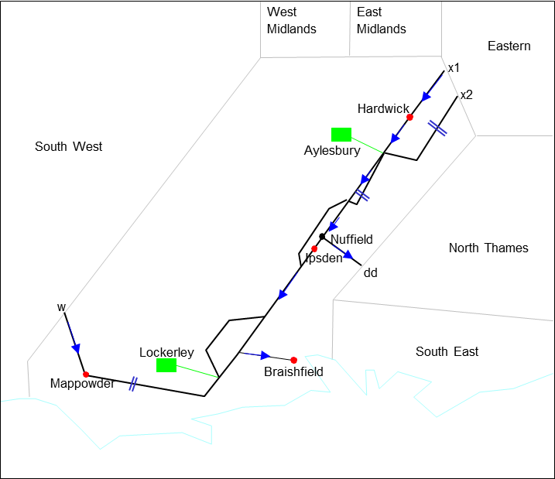



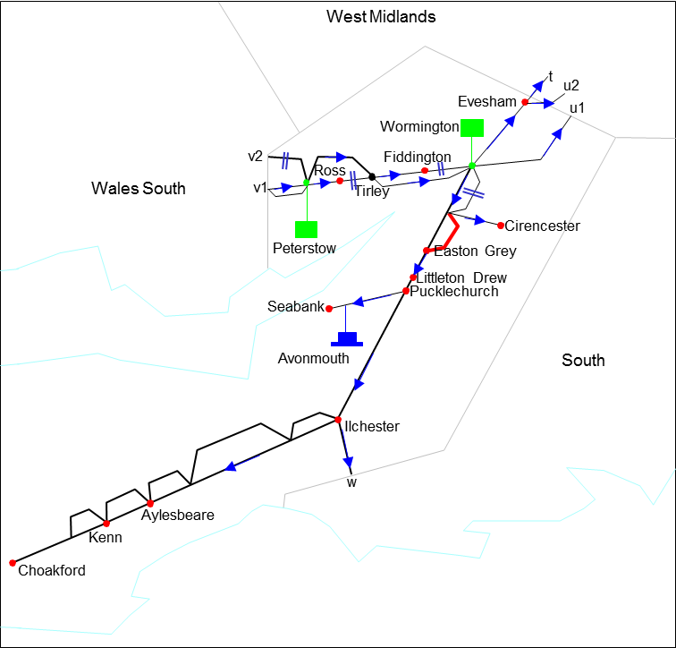

# Annex 2: PARCA Supporting Information

**PARCA Phases Overview**[30]:

|  |  |  |  |
| --- | --- | --- | --- |
| PARCA Phase | Activities | Approximate Timescales | Activities and Outputs |
| 0 | Pre-PARCA Signature discussions |  | Bi-lateral discussions between National Gas Transmission and a customer before a PARCA has been agreed.  *This is not technically a PARCA Phase however it has been included for completeness* |
| 1 | PARCA Application Window & ad-hoc QSEC Auction (if required)  Network Capability Assessment & Investment Options Identified | Up to 6 months | The PARCA Application Window would be opened and National Gas Transmission would undertake an Ad-hoc QSEC Auction if a PARCA Application requesting NTS Entry Capacity has been accepted.  We would undertake network analysis to determine how the requested level of capacity could be provided to the PARCA Applicant / Applicants given our existing capacity obligations and forecast future supply and demand patterns.  We would make best use of existing system capability and / or NTS Capacity substitution, before considering investing in increased system capability. If network investment is required, we would determine the different available investment options.  The outputs of the PARCA Phase 1 process would be issued to the PARCA Applicant in order that they can confirm whether they wish to proceed to PARCA Phase 2. |
| 2 | Capacity Reserved & Planning Submission Activities undertaken | Up to 60 months | Upon confirmation from the PARCA Applicant that they wish to proceed to PARCA Phase 2, the level of NTS Capacity identified in the PARCA Phase 1 outputs would be reserved at the appropriate NTS Exit and/or Entry Points for the PARCA Applicant.  National Gas Transmission would undertake the appropriate works, if required, and will progress investment design works and an appropriate planning application. PARCA Phase 2 would apply up to receipt of planning approval.  If no planning works are required to provide the NTS Capacity to the PARCA Applicant, it will be reserved until their respective capacity allocation date as identified in the PARCA Phase 1 outputs. |
| 3 | Capacity Allocation & Construction Activities | Up to 24 months | Following the completion of PARCA Phase 2 activities and upon confirmation from the PARCA Applicant, the reserved NTS Capacity will be allocated and construction activities (if required) would begin.  If a contractual or commercial solution can be agreed as an alternative to construction then it would also be finalised and agreed during PARCA Phase 3.  Upon allocation of any reserved NTS Capacity, UNC User Commitment applies. |

**PARCA Scenarios**:

National Gas Transmission has produced a set of slides which describe examples of interacting projects which were presented at Transmission Workgroup. Please select the following link to access these slides:

<https://www.gasgovernance.co.uk/index.php/tx/310113>

1. This Statement is often abbreviated to the “ExCS”.
2. The gas National Transmission System
3. For the avoidance of doubt, references to ***Obligated Exit Capacity*** can be taken to mean **Technical Interconnection Point Capacity** with regards to Exit Interconnection Points.
4. For the purpose of this Statement, references to NTS Exit Points can be taken to include Interconnection Points where it regards consideration as a donor NTS Exit Point. An Interconnection Point NTS Exit Point may also be referred to in this Statement as an Exit IP.
5. A PARCA, a “Planning and Advanced Reservation of Capacity Agreement”, is a bilateral agreement which allows non-code parties (Reservation Parties) or Users (Reservation Users) to reserve **Quarterly NTS Entry Capacity** and / or **Enduring Annual NTS Exit (Flat) Capacity** ahead of its registration to the User or, as the case maybe, a Nominated User (nominated by the Reservation Party).
6. An IP PARCA, an “Interconnection Point Planning and Advanced Reservation of Capacity Agreement”, is a bilateral agreement allowing a Shipper User, or a Reservation Party, to apply for Interconnection Point Capacity above the prevailing level of Technical Interconnection Point Capacity, at an Exit IP. Provision of a demand indication in accordance with UNC EID E, is the method by which the Shipper User or Reservation Party can participate in the IP PARCA process. National Gas Transmission will not release Funded Incremental Obligated Exit Capacity, at an Exit IP, by any other process.
7. For the avoidance of doubt this includes Technical Interconnection Point Capacity at Exit IPs.
8. Dated 13 July 2009 and concerning conditions for access to the natural gas transmission networks.
9. A PARCA may be entered into at any time for the purpose of the reservation of Enduring Annual NTS Exit (Flat) Capacity
10. The ExCR defines circumstances where Users can reduce their registered capacity holding to facilitate substitution. This “allocated” capacity will become Substitutable Capacity if the reduction request is accepted.
11. The Licence only allows the substitution of ***Non-incremental Obligated Exit Capacity*** to meet the demand for ***Incremental Obligated Exit Capacity*** at another NTS Exit Point. Consequently it is only possible to substitute such previously released incremental capacity, where it is unsold, once it has been reclassified as ***Non-incremental***

    ***Obligated Exit Capacity*** at the date defined in the Licence.
12. i.e. in accordance with UNC processes, including a PARCA or IP PARCA, and the ExCR as appropriate.
13. For the avoidance of doubt at an Exit IP this is equivalent to the demand indication phase and the design phase.
14. “ A financial commitment is not the User Commitment needed to trigger incremental capacity release
15. References in this document to years “Y+2” etc relate to capacity years, i.e. year Y is the year of the relevant application or the year of reservation via a PARCA or IP PARCA.
16. Please note that existing unsold NTS Exit Capacity may be withheld from an application window if is identified as substitutable capacity that could potentially be used to satisfy capacity demand via an IP PARCA. If this is the case it would be identified in the relevant application window invitation letter.
17. UNC TPD Section B1.16.4 includes provisions that provide an option for the initialisation of the Phase 1 PARCA works to be delayed by National Grid until the outcomes / impacts of the annual application process are known. This allows any interactions of the PARCA and Application processes to be assessed and considered on a case by case basis.
18. For the avoidance of doubt, where this statement refers to ‘Exit Capacity applications’, this includes PARCA and IP PARCA Applications.
19. An NTS Exit Point shall be considered to have been disconnected if the connection to the NTS has been isolated and the associated connection agreement (e.g. Network Exit Agreement) has been terminated.
20. Assuming partial substitution is allowed.
21. As defined in Chapter 3.
22. Or contractual alternative.
23. This would include NTS Exit Points that have a high degree of interactivity with, and those located downstream of, the recipient NTS Exit Point. Hence, in order to ensure a supply / demand match, these points will be determined individually for each recipient NTS Exit Point.
24. For the avoidance of doubt, in this paragraph “off-peak” refers to gas demand at levels below peak requirement and should not be confused with Off-peak Daily NTS Exit (Flat) Capacity.
25. 0.1 GWh/d is the lower limit to which network analysis tools can meaningfully be applied.
26. Residual investment is the investment remaining (if any) after all substitution opportunities have been exhausted in accordance with Exit Capacity Substitution. National Grid may consider alternatives to investment.
27. Additional proposals may be made to the Authority in the event that circumstances change between the end of Phase 1/design phase and allocation of capacity. Such circumstances may include Substitutable Capacity becoming available through a User reducing its registered Capacity.
28. i.e. where there is a high degree of interaction between the NTS Exit Point and ASEP.
29. Where Exit Capacity Revision leads to increases in the Licence Baseline Exit Capacity at actual NTS Exit Points, this will be included in the notice made pursuant to paragraph 77.
30. Phases 2 & 3 only are also applicable to the IP PARCA process.