**Rough Storage Data**

* Storage Injection data is available in ‘Rough, Storage’ data items.
* Storage Withdrawal data is available in ‘Rough’ data items.
* ‘Rough-Sub’ is for UK Continental Shelf supplies via Rough NTS entry point (example below). This includes the gas supplied from the Humber Gathering System in the Southern North Sea.
* Instantaneous Flows are aggregated.
* Capacity and nominations data items are also available for withdrawal at an ASEP for Rough Storage.
* The Daily storage and LNG info report includes Rough Storage.

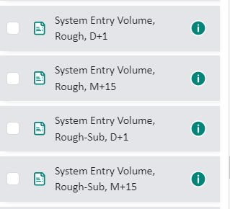**Where to find information:**

Gas Data Portal:

<https://data.nationalgas.com/find-gas-data>

Daily Storage and LNG Info report:

<https://www.nationalgas.com/data-and-operations/transmission-operational-data>



REMIT Inside Information notifications:

<https://www.remit.gb.net/>

**Note**: Easington Terminal total does not include York Sub Terminal when looking at *Supply from terminals* on the following page: <https://data.nationalgas.com/gas-flows/latest>