Locational Trades at GB Points
Operational Guidance Material

January 2019

This document forms part of a suite of documents created to provide operationally focused guidance material; the aim of which is to support Shippers in increasing their understanding of non-routine commercial tools utilised by National Grid so that Shippers can be suitably prepared and ready to participant ahead of an event.
Operational Guidance Material
The Operational Guidance Documents detail the optimum way to perform the relevant process based on the current systems available. Where there are alternative ways in which the process could be completed the associated risks and benefits are explored.
These documents are not intended to be used as detailed operating process / procedures; however, they can be used by each Shipper organisation to assist in creating the operational process steps that are right for them.
These documents do not preclude changes or development to commercial tools in collaboration with industry in the future.

Gas Locational Trades Information Overview

This document outlines the circumstances in which Gas Locational Trades can take place and provides more information regarding the Locational Trades at GB Points process. The following topics are covered:
- The objective of Locational Trades
- Circumstances where Locational Trades can occur
- Overview of Locational Trades at GB Points Process
- Shipper / User Actions
- Submitting Locational Trades on GEMINI
- Additional Information

Objective of Locational Trades
Locational Trades allow National Grid to address localised supply / demand imbalances impacting the National Transmission System (NTS). Following a locational trade a change in physical flow is expected, with the aim of managing either NTS Entry & Exit Capacity Constraint risk or NTS Linepack risk.
Locational trades can be done at any single point (entry or exit) on the NTS, this can be at an Interconnector Point (IP) or a non-interconnector point.

Circumstances where Locational Trades Can Occur

National Grid may trade gas at specific NTS entry and exit locations in the following events:
- NTS constraints to increase or reduce the actual flow rate.
- Gas Deficit Warning or Margins Notice to address the Linepack position in the NTS.
This list is not exhaustive and the decision to request locational / physical bids and offers will be based on the exact scenario facing the Gas National Control Centre (GNCC) on any specific day.

Overview of Locational Trades Process at GB Points

In an event where National Grid requires locational trades to take place an Active Notification System (ANS) message calling for locational bids/offers will be sent out, the details of which, will be dependent on the current situation. Once the ANS message has been issued locational bids/offers can be submitted in WebICE and then, if accepted, logged on GEMINI.

Figure 1: Process Overview

* National Grid will work through the bids/offers in line with the System Management Principle Statement.

The sequence of process steps depicted in Figure 1 and throughout this document is the recommended process to minimise risk to the NTS under the difficult circumstances where locational trades are necessary.

The timeline for placing locational trades can be seen in Figure 2. If a bid is accepted by National Grid the Shipper must confirm the locational trade within the GEMINI system within 60 minutes, otherwise a Physical Renomination Incentive charge (PRI) will be incurred.

By accepting the bid on GEMINI Shippers are confirming they can deliver the traded quantity.

Figure 2: Timeline for locational trade submission

0 minutes
60 minutes
Bids/ offers placed on WebICE by Shippers
PRI charges are now applicable if trade is not confirmed on Gemini
National Grid issue ANS calling for locational bids/offers
Bids/ offers accepted on WebICE by National Grid
Bids/ offers logged on Gemini by GNCC .
Bids/ offers confirmed on Gemini by Shipper

Shipper / User Actions
For the Locational Trade process to function correctly it is expected that Shippers will complete the following actions:
- Maintain ANS contact details to ensure important messages are received.
- Add the locational market to the portfolio view on WebICE ready for trading.
- Promptly place bids/offers on WebICE on receipt of ANS notifications.
- Have the correct capacity and nomination arrangements in place to support any accepted locational trades.
- Maintain awareness of trade status on both WebICE and Gemini.
- Confirm any accepted trades on Gemini within 60 minutes of GNCC registering the trade on Gemini.

Submitting Locational Trades on GEMINI

The following section will provide information on how to submit locational trades on GEMINI for Locational Trades at GB Points only.

- Before submitting a locational trade on WebICE, Shippers should ensure the associated capacity rights are in place. Failure to do so risks incurring Capacity Overrun charges.

- Locational bids/offers to be placed on WebICE as per usual processes with the addition of the relevant location code. Location codes can be found on the WebICE website using the following link: https://www.theice.com//publicdocs/endex/ICE_Endex_UK_OCM_Gas_Spot_Locational_Products.pdf

- National Grid will assess all bids/offers and select the appropriate trades to accept based on the methodology set out in the System Management Principle Statement.

- Shippers should monitor the status of the locational trade on WebICE; this can be done via various mechanisms, such as pop-ups, updates to the Shipper ticker at the bottom of the WebICE screen and viewing the deal tab. WebICE functionality allows Shippers to add sound effects to aid awareness of bid/offer acceptance.

- If National Grid accepts your trade, you must monitor your GEMINI account so that you are aware as soon as your trade is registered. To do so navigate to Home > OCM > Trade Details > Physical / Locational Trade Status.

NOTE: It is the Shippers responsibility to makes sure they are aware of their trade status. Locational trades are subject to charges if the trade is not confirmed on GEMINI within 60 minutes of the time the trade is logged on GEMINI (see Figure 2 for more details).

- Once National Grid have accepted the trade, the GNCC will log the trade on Gemini using the details of the trade provided by WebICE via the following screen:
Home > OCM > Trade Details > Physical / Locational Trade > Register.
Unless stated otherwise, all details are entered from the WebICE trade screen.
Details of the trade to be entered:

Bid ID:
Bid Type: L for locational
Bid Originator:
Bid Timestamp:
Location:
Buy/Sell:
Start time:
Traded Quantity:
Price:

Once the GNCC have pressed the ‘Register’ button the locational trade will be officially logged on Gemini.

NOTE: At this point the 60 minutes countdown begins. If the next step is not completed within 60 minutes the Shipper will be exposed to PRI charges. Please note, at this stage the trade will not be viewable on the BA screen.

- The Shipper now needs to confirm the trade. To do so navigate to home > OCM > Trade Details > Physical / Locational Trade Status. Select the trade by ticking the left-hand circle. Once selected press the ‘Maintain OCM Renoms’ button.

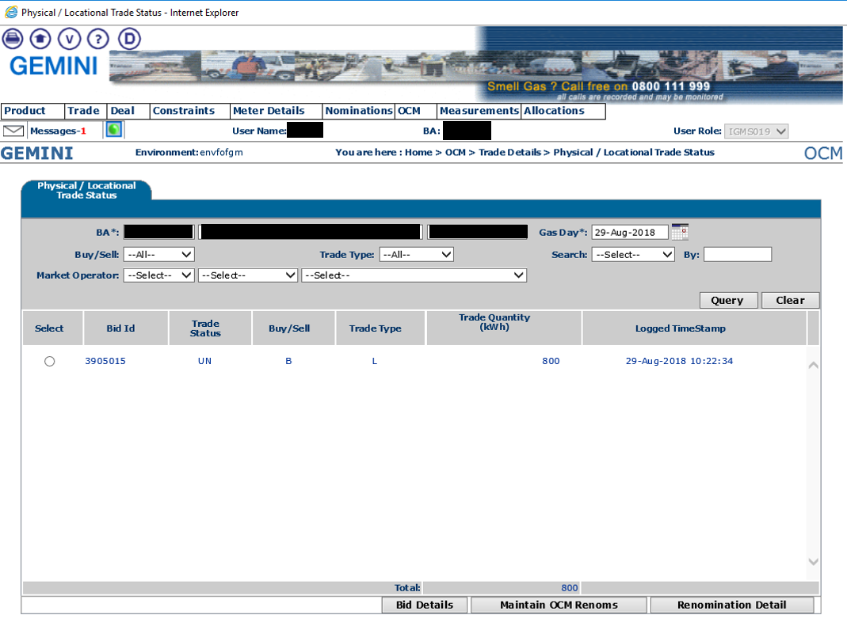

- On the subsequent screen a button will be visible at the bottom of the screen saying ‘Confirm LOC’. Select the trade via the left-hand box and press ‘Confirm LOC’.

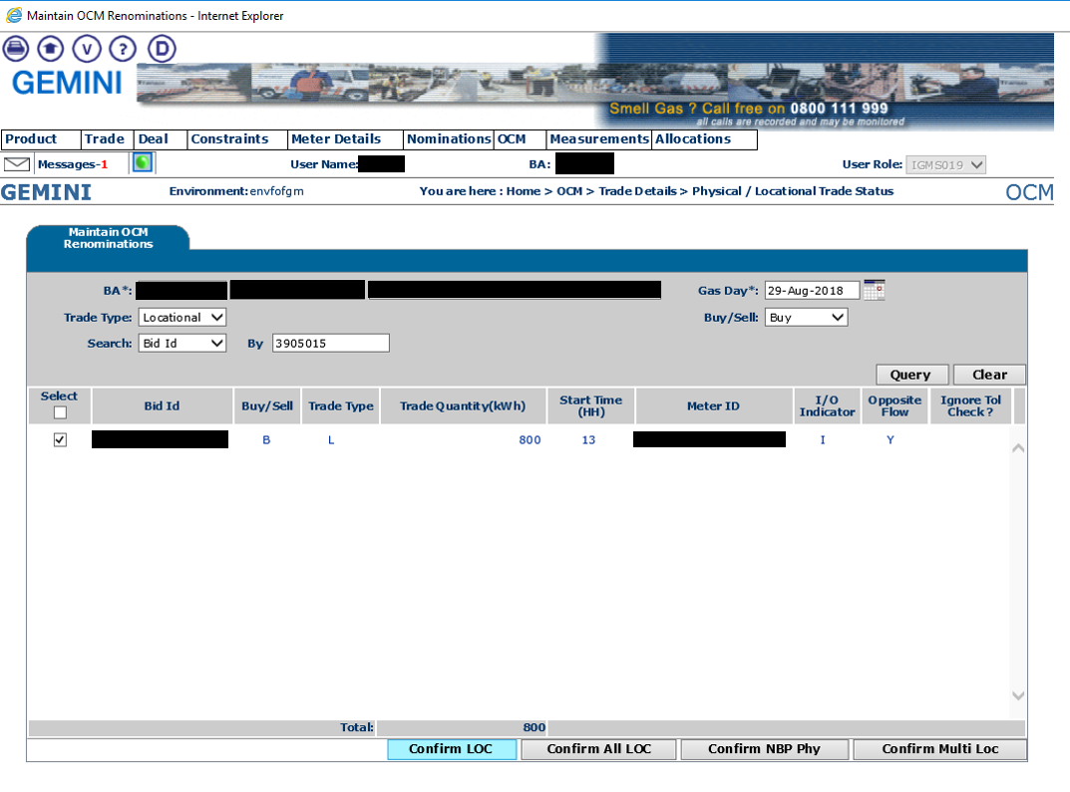

- The trade is now accepted and will be visible on the Shipper Business Associates (BA) screen.

Additional Information
Contact for more information
Capacity Team, GSO - capacityauctions@nationalgrid.com

National Grid plc
National Grid House,
Warwick Technology Park,
Gallows Hill, Warwick.
CV34 6DA United Kingdom
Registered in England and Wales
No. 4031152

nationalgrid.com

